EVERYDAY LIFE IN VIKING TIMES
There are spelling errors and missing capital letters.
Read the passage carefully and then underline the errors and write the correct words above.
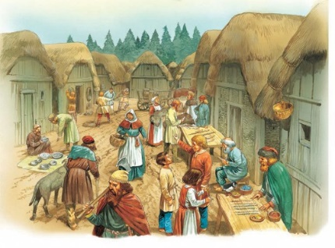

Most Vikings were farmers they grew crops such as barley, oats and rye and kept cattle, goats, sheep, pigs, chickens and horse. In most parts of Scandinavia, people lived in timber houses, but in places were wood was scarce they built with turf or stone instead. Some Vikings worked as fishermen, catching freshwater and sea fish as well as hunting for whales. Salt was a vital commodity, usually bought from travelling merchants. It was used to preserve fish and meet to eat during the long winters, when fresh food was scarce.

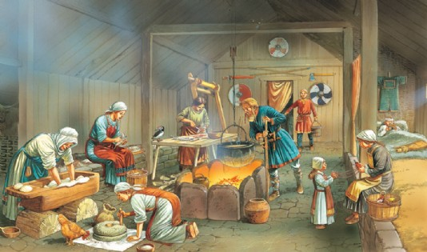
Nearly all houses and workshops were made of timber. They were long and rectangular. The roofs were maid of reeds or straw thatch. Other than at a blacksmith’s forge, there were no chimneys, only openings to allow smoke from the hearth to escape. some poorer dwellings may have had just a single room with a hearth in the centre. With no windows, interiors were gloomy, lit by simple oil lamps or candels. People busied themselves with work such as cooking, drying, salting, smoking and pickling food, tanning leather, blacksmithing, or scouring and dyeing cloth.

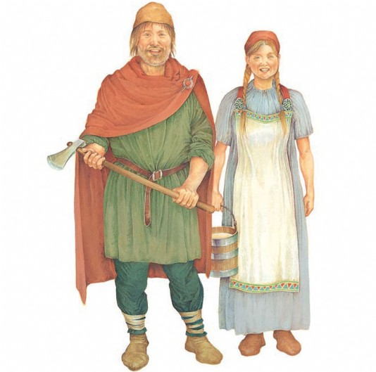
The clothes of the Vikins were simple and practical, made from woollen or linen cloth, with animal skins to keep warm in the winter. Men wore trousers and a long-sleeved shirt or tunic, while women wore loose-fitting dresses, usually with an apron ove the front. In cold weather, both men and women wore cloaks, fastened by a brooch. Shoes was made from leather.

