Year 5/6 Homework for Summer 1
Year 6
In the run up to SATs, Year 6 should continue to use the https://www.satsbootcamp.co.uk/sbc/ website. You have got your own individual login for this website but if you forget it, Mr M knows what it is so just ask. Try and do at least one arithmetic test, one reasoning test, and one of the reading tests. (Not long to go now…)
Year 5 | Hand-in date
Topic – As we have begun learning about the rivers in South Devon, carry out research on a famous river from another part of the world and make a poster to show what you have found out. | 08/05/19
Write a short character description of a hero or villain from one of your favourite films or books. Try to use really exciting vocabulary and include an illustration. | 15/04/19
Maths Maze  In this maze there are numbers in each of the cells. You go through adding all the numbers that you pass. You may not go through any single number more than once.  Can you find a way through in which the numbers add to exactly 100?  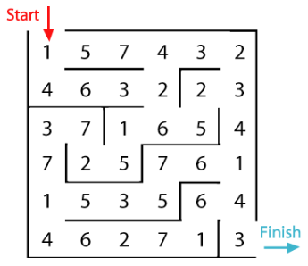  What is the lowest number you can make going through the maze?  What is the highest number you can make going through the maze? (Remember you may not go through any cell more than once.) | 22/04/19

