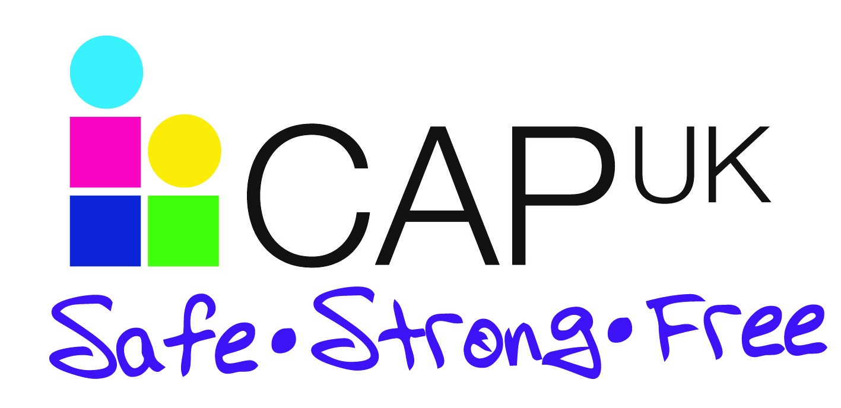
Your CAP UK team will running three-hour workshops with each class next week….
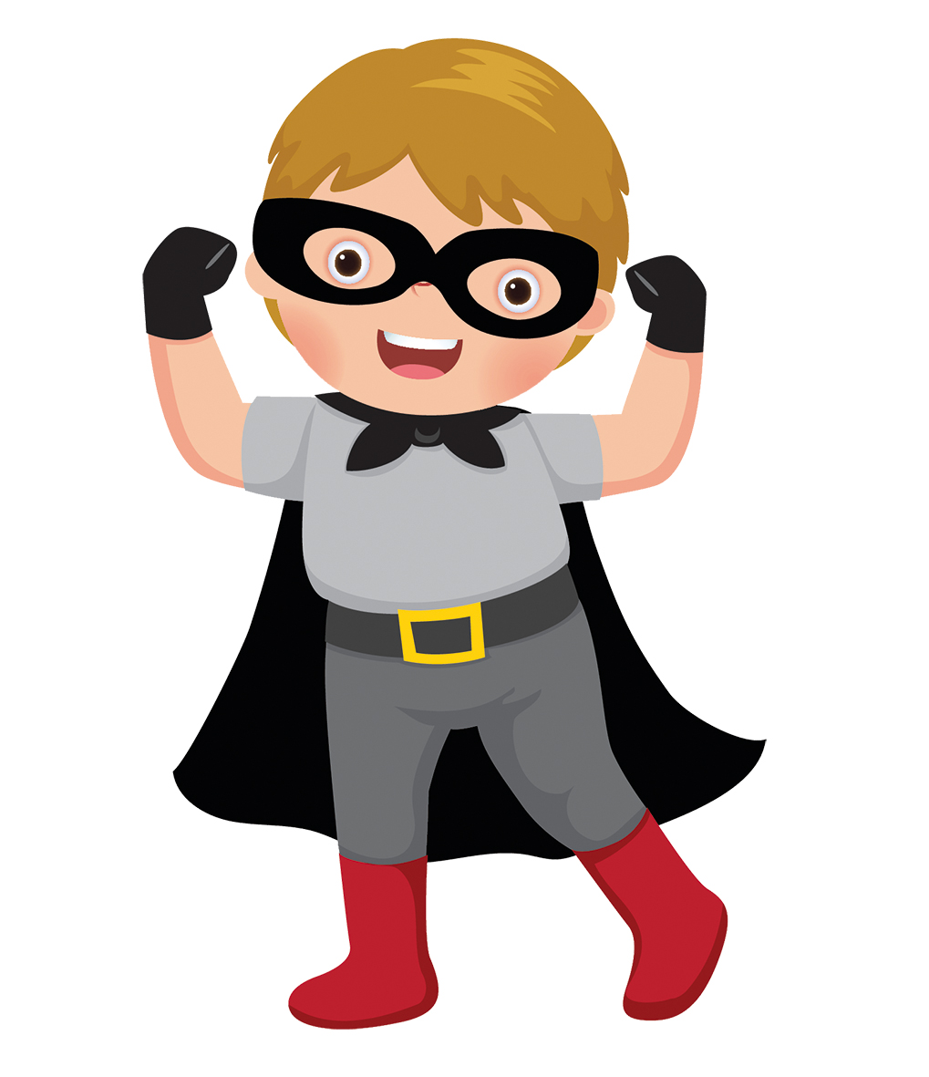
Come and meet us!
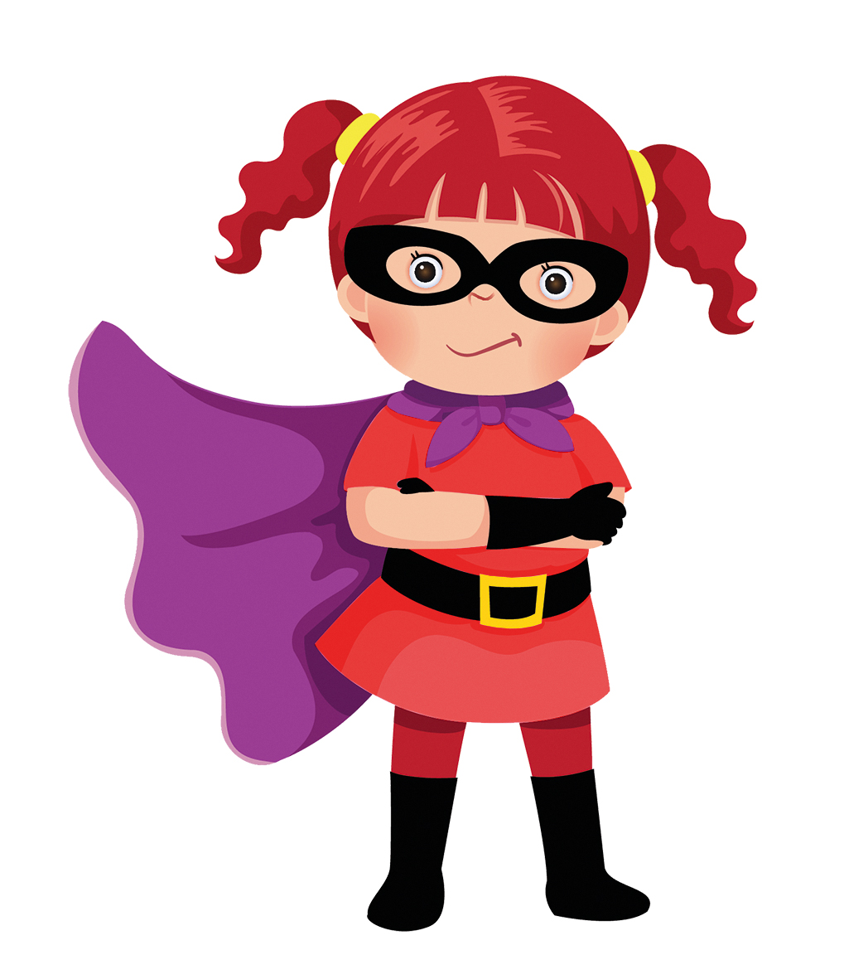
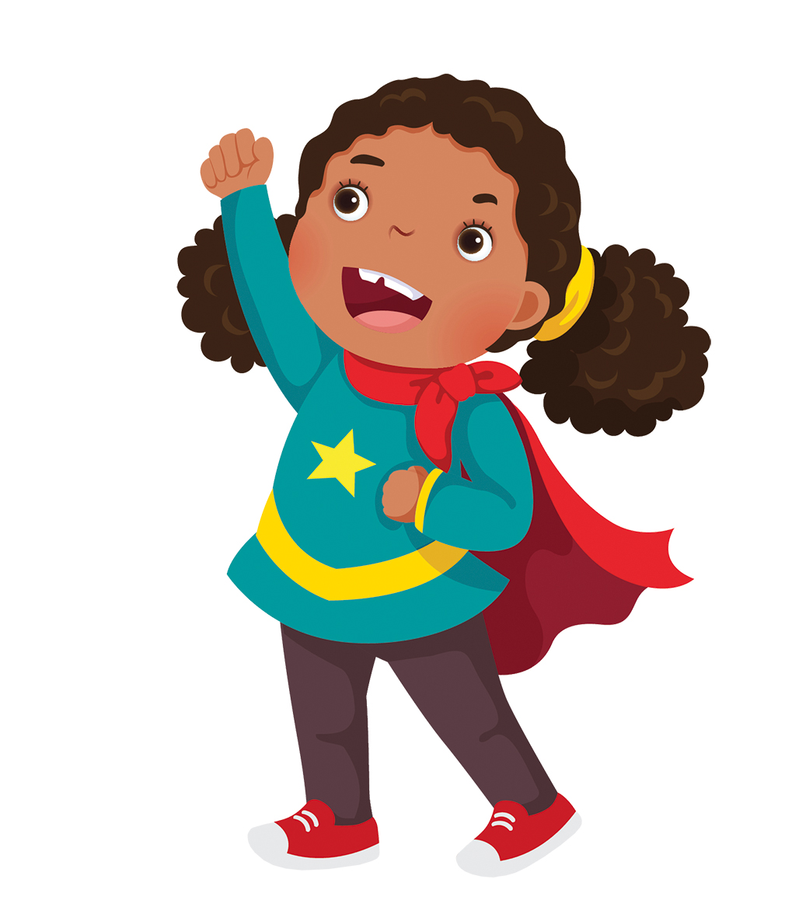
- Find out about our work
- Get top tips on how you can help keep your children safe in the modern world and help them to grow into strong, confident people.
Our workshops are designed to build children’s confidence and self-esteem, they are lively and fun. Come and see what we do to teach children knowledge and strategies to deal with some of the more difficult aspects of growing up. We’ll discuss keeping safe around bullies, the internet, strangers and known adults and answer any questions you may have.
Our Parents’ information session is your chance to see what we do, your chance to have your say, your chance to get advice, information and resources. Come along!
Where: Grove Primary School
When: Monday 14th October @2.00-3.00pm
Book your place with your school office staff. Parent workshop is not suitable for children.
Connect with us online: Facebook: @safestrongfree | www.safestrongfree.org.uk

