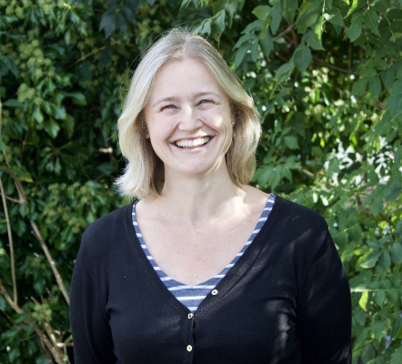

I grew up in Totnes and went to the local schools for my Primary and Secondary education. I went to Rolle College in Exmouth to train to be a teacher and hold a B’Ed Hons degree. I started as a Governor at The Grove School in September 2020. I am the staff governor. I am responsible for providing feedback to the governors about the curriculum and informing staff about the governor’s strategic intents. I have worked at the Grove for 19 years. I am currently the Deputy Head which is currently a non-teaching role but I have been a teacher since 1996. My main area of expertise is KS1 but I have also taught KS2 children. I am currently responsible for Literacy and Numeracy within the school. It has always been a real privilege to have taught so many wonderful children in Totnes even though it does make me feel old now that some of the children I have taught are now returning to The Grove as parents themselves!

