Year 5/6 Homework for first Spring half-term
This term the homework will all be online but it is dated so every week there is a different task to hand-in. If you want you can do multiple homeworks in the same week but they will be marked/checked on the hand-in dates. Homeworks will be given out on Fridays and handed in on Wednesdays. Remember to also check your spellings and whether you have any reading tasks to do in your reading diaries.
Task | Hand-in date
Topic – Vikings Mythology  As we get started with our Viking topic, we would like you to research the Norse Gods. Choose one and create a short fact file about your choice. Please include an illustration. | 16/01/19
Maths - Nets  A net is a shape that can be folded up to make a 3D shape. This week we would like you to draw all the nets you can think of that could be folded to make a cube. Here’s one to get you started!  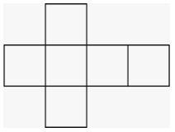  You will need to use squared paper. (There are 11 different ones to find – not including reflected or rotated shapes!) | 23/01/19
SPaG – Proof-reading  (Will be appearing soon!) | 30/01/19
PSHE – Healthy eating  As part of our science topic, we will be learning about the effects of a healthy diet on our bodies. Mr M has noticed that not all the snacks eaten at break times are as healthy as they could be.  We would like you to create an information leaflet – A Guide to Healthy Snacks. The leaflet is aimed at children in years 1-4 so you will need to make sure that your ideas appeal to them!  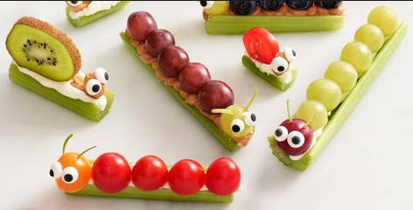 | 06/02/19
Art: Viking artefacts  (Watch this space!) | 27/02/19

