Year 5/6 Homework for first Spring half-term
This term the homework will all be online but it is dated so every week there is a different task to hand-in. If you want you can do multiple homeworks in the same week but they will be marked/checked on the hand-in dates. Homeworks will be given out on Fridays and handed in on Wednesdays. Remember to also check your spellings and whether you have any reading tasks to do in your reading diaries.
Task | Hand-in date
Topic – Vikings Mythology  As we get started with our Viking topic, we would like you to research the Norse Gods. Choose one and create a short fact file about your choice. Please include an illustration. | 16/01/19
Maths - Nets  A net is a shape that can be folded up to make a 3D shape. This week we would like you to draw all the nets you can think of that could be folded to make a cube. Here’s one to get you started!  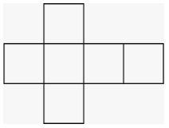  You will need to use squared paper. (There are 11 different ones to find – not including reflected or rotated shapes!) | 23/01/19
SPaG – Proof-reading  (Will be appearing soon!) | 30/01/19
PSHE – Healthy eating  As part of our science topic, we will be learning about the effects of a healthy diet on our bodies. Mr M has noticed that not all the snacks eaten at break times are as healthy as they could be.  We would like you to create an information leaflet – A Guide to Healthy Snacks. The leaflet is aimed at children in years 1-4 so you will need to make sure that your ideas appeal to them!  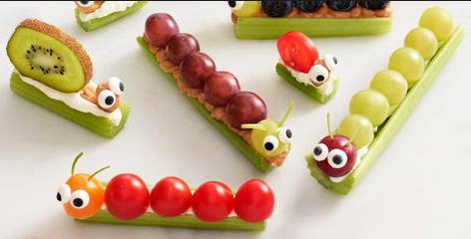 | 06/02/19
Banana Bird or Banana Animal – Y5  Soon after half term, Y5 will be going to a fair trade event which will be extremely exciting and interesting. At this event, a competition is always run and so this year we are asking that you make a banana bird or banana animal as your entry for this competition. You might find some ideas online to inspire you e.g. lambananas (Liverpool).  Be as creative as possible. Have fun! | 27/02/19
Art: Viking artefacts – Y6  To keep those minds focused on the Vikings, over half term we would like you to carry out some research into artefacts that would have been used in Viking times.  From this fantastic research, we would then like you to make your artefact.  Think: how will you join parts together? What colours are you going to choose? Is it durable? Strong? Will it do the job it is designed for?  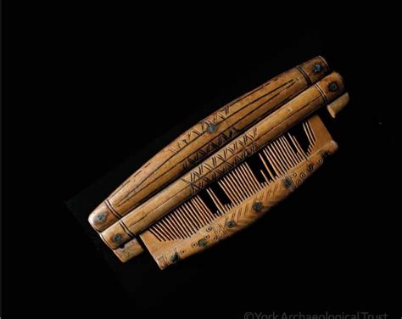  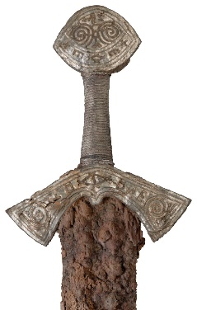  Most of all – be creative!  Viking Comb Part of a Viking sword | 27/02/19

