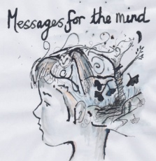
LOOKING FOR A CHRISTMAS PRESENT – BUY GINKGO’s BOOK FOR £2.00
Ginkgo class have made a book. It’s called… Messages for the Mind.
Printed professionally, this book includes 32 pages of motivational words and artwork designed to lift your spirits during these difficult times. To view a preview of the book, visit Ginkgo class’ webpage and click on the PDF at the bottom of the webpage …
http://www.the-grove-primary.devon.sch.uk/web/year_5_and_6_ginkgo_tree_class_autumn_term/498158
Limited availability so buy multiple copies for all your extended family members. To order, fill in the form below and return by Friday 20th November. Alternatively, email admin@the-grove-primary.devon.sch.uk for an order form.
Books delivered approximately first week of December.
--------------------------------------------------------------------------------------------------------------------------------------

I would like to order __________ copies of Messages for the Mind.

I enclose £__________ (each copy of the book = £2.00)

Name of child: _________________________________ Class: ______________________

Name of Parent: _________________________ Contact number: _____________________
--------------------------------------------------------------------------------------------------------------------------
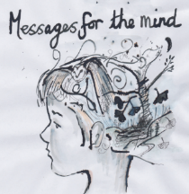
LOOKING FOR A CHRISTMAS PRESENT – BUY GINKGO’s BOOK FOR £2.00
Ginkgo class have made a book. It’s called… Messages for the Mind.
Printed professionally, this book includes 32 pages of motivational words and artwork designed to lift your spirits during these difficult times. To view a preview of the book, visit Ginkgo class’ webpage and click on the PDF at the bottom of the webpage …
http://www.the-grove-primary.devon.sch.uk/web/year_5_and_6_ginkgo_tree_class_autumn_term/498158
Limited availability so buy multiple copies for all your extended family members. To order, fill in the form below and return by Friday 20th November. Alternatively, email admin@the-grove-primary.devon.sch.uk for an order form.
Books delivered approximately first week of December.
--------------------------------------------------------------------------------------------------------------------------------------

I would like to order __________ copies of Messages for the Mind.

I enclose £__________ (each copy of the book = £2.00)

Name of child: _________________________________ Class: ______________________

Name of Parent: _________________________ Contact number: _____________________
--------------------------------------------------------------------------------------------------------------------------

