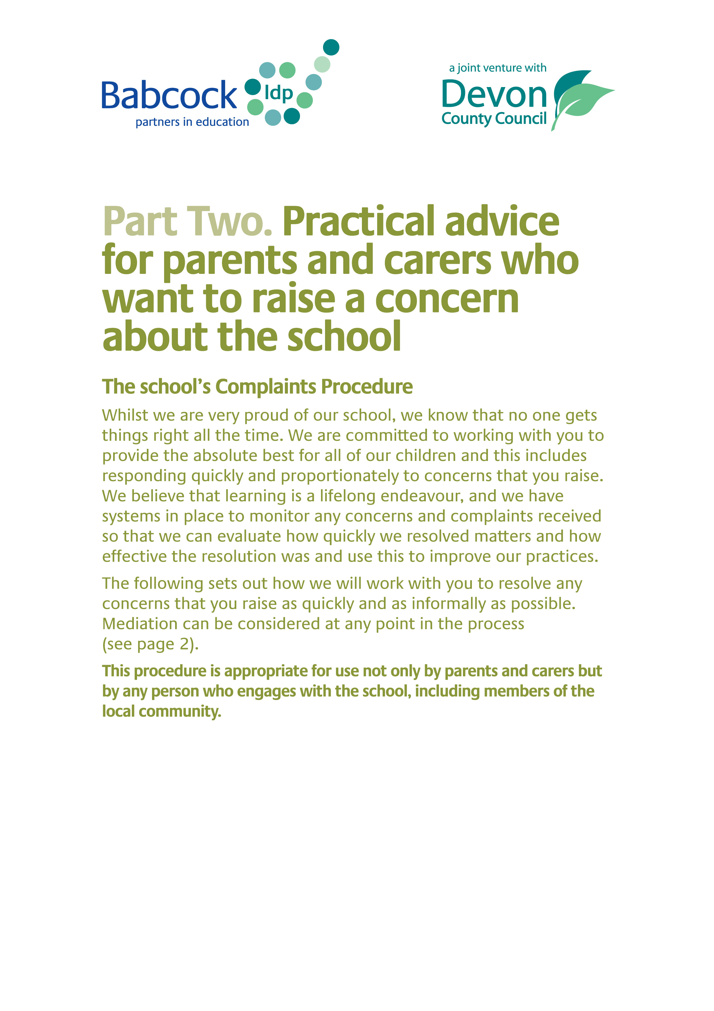

School Resolution (Informal Stage)

If you are concerned or unhappy with the way the school or a member of its staff has treated you, or you are concerned or unhappy with the way the school is operating its policies and procedures, then you can raise your concerns or make a complaint.

Usually the best way to deal with a concern or complaint is for the member of staff, headteacher or school governor to talk with you so that they can understand what your concern or complaint is about, and take any appropriate action to put things right. The school will determine who is most appropriate to carry this out depending on the nature of the concern.

The person dealing with your concern may also want to take the opportunity to explain what has happened from the perspective of the school or staff member involved. Low level concerns or complaints can be dealt with quickly and effectively by the headteacher or a governor using this approach, which is known as a ‘School Resolution’.

This way of dealing with your concern or complaint means solving, explaining, clearing up or settling your concern or complaint directly with you. It will not result in conduct or capability action being taken against an individual member of staff, and the complaint will be closed after the process is completed.

Resolving your complaint in this manner can help to improve the service
your community receives from the school.

How does the School Resolution process work?
Once you have raised your concern or complaint, the person who is looking into it will contact you within 5 working days (in term time). They can arrange to talk to you face-to-face, on the telephone, or they can contact you by letter or email if you prefer.

For your part, you will need to:

- tell the school what happened and how you felt about it
- say what action you would like to see taken as a result
- agree the process for resolving your concern or complaint

This School Resolution process is not about apportioning blame or about staff being dealt with through formal conduct or capability procedures – schools are centres of learning for everyone, and it is about learning from what has happened and working with you to make sure it doesn’t happen again.

For its part, the school will:

- listen to your concerns
- explain what can happen to resolve your concern or complaint
- confirm with you the process that will be followed and who will deal with it
- if necessary, carry out a more detailed investigation into your concern or complaint. This is called a ‘School Investigation’ (see section on ‘School Investigation’ at the end of this document)

- provide information for parents and carers of children with SEND (Special Educational Needs and Disability) about how they can access support from The Devon Information Advice and Support service (this is a requirement in the SEND Code of Practice)
www.devonias.org.uk 01392 383080,
devonias@devon.gov.uk

What can I expect from the School Resolution?

Most concerns or complaints are not likely to involve extensive or lengthy enquiries, and therefore you should expect an approach that is proportionate to the issue you have raised.

As the School Resolution process is aimed at quickly resolving your concern or complaint and learning from it, it won’t lead to conduct or capability proceedings against a member of staff. However, where appropriate, the member of staff might receive further support or training as a result.

If your concern or complaint is an expression of dissatisfaction with something the school has either done or not done, and not about somebody - for example, about the way the school operates its policies or is directed to fulfil its statutory obligations - then it will still be resolved using this ‘School Resolution’ approach.
Mediation
Sometimes during the handling of a complaint, communication between parents and the school can become difficult. Mediation can be a very useful way of helping people to resolve their differences and find an agreed way forward. Both parties need to agree to mediation. The school (or the parent) may suggest mediation, if communication becomes a problem.

Mediation can be sought at any point during the processes of resolution and investigation. The mediation process is informal, impartial and voluntary, and aims to resolve conflicts to the benefit of all. It does not apportion blame and concentrates on developing a better understanding of each other’s point of view and works to secure future relationships. For more information, please contact: 07966 474364.

For issues raised relating to SEND (Special Educational Needs and Disability) resources, specialist mediation is a requirement in the SEND Code of Practice. For more information please contact The Devon Information Advice and Support service: devonias@devon.gov.uk.

What happens next?

There are different ways of dealing with the concern or complaint using
The School Resolution Process. These include:

- immediate resolution by providing information face-to-face
or by telephone, as you choose
- a letter from the school concluding the matter after proportionate consideration, explaining what has been done
- individual communication between you and the person your concern or complaint was about and/or a face-to-face meeting with the person your concern or complaint was about. The person your concern or complaint was about will need to agree to a face-to-face meeting taking place

When the named person has looked into your concerns you will receive further communication from the school within 10 working days of the original concern being raised. However, if the concern is complex, the person working on the School Resolution may contact you to let you know that more time is needed to look more fully into the matter.

What might happen as a result?

The school could take the following actions to resolve your concern or complaint:

- give you information or an explanation to clear up a misunderstanding
- apologise on behalf of the school
- learn from the issue, accepting that something could have been handled better and explaining what has been done to stop the same thing happening again
- arrange action by the headteacher to address an issue with a member of staff through support and development
- apologise on behalf of the person your concern or complaint was about but only if they agree to this
- arrange action by the Governing Board to address matters of policy or procedure

School Investigation – The Formal Complaints Procedure (Stage 1 and 2)

If the complaint is about the headteacher or one of the governors, then any letter of complaint should be addressed to the Chair of Governors c/o the school. If the complaint is about the Chair of Governors, then this should be addressed to the vice chair of governors.

Stage 1 will be carried out by the headteacher, a delegated member of staff or a governor in the school. If the complaint relates to the headteacher the complaint will be investigated by a governor.

Although this is a formal investigation into your complaint, it will still be in the spirit of quickly reaching an effective outcome and maintaining positive and productive relationships. All parties need to work together to maintain productive relationships, and establish a way forward in partnership. This investigation may call for more information to be gathered before the person investigating can explain what has happened from the perspective of the school or the staff member involved. This way of dealing with your concern or complaint means solving, explaining, clearing up or settling your complaint directly with you, but doing so with a more detailed investigation than at a School Resolution level.

How does the School Investigation process work?

Once you have raised your concern or made your complaint, the headteacher, member of staff or governor who is looking into it will contact you within 5 working days (term time). They can arrange to talk to you face-to-face, on the telephone or they can contact you by letter or email if you prefer.

For your part, you will need to:

- tell the school what happened and how you felt about it
- say what action you would like to see taken as a result
- agree the process for resolving your concern or complaint
- agree timescales and pathways for communication

For its part, the school will:

- listen to your concerns
- explain what can happen to resolve your concern or complaint
- confirm with you the process that will be followed and who will deal with it
- carry out a more detailed investigation into your concern or complaint
- produce and supply all parties with a written report of the findings
- ensure that any relevant findings are taken forward to influence school practice and policy

What can I expect from a School Investigation

Some concerns or complaints may demand more detailed and perhaps time consuming enquiries, and therefore you should expect an approach that is proportionate to the complaint you have made. The person investigating your concern should keep in regular contact to keep you informed of progress on the matter.

Nevertheless, the School Investigation process aims to quickly resolve your concern or complaint and identify any learning from it.

What happens next?

Your concern or complaint will be the subject of a proportionate investigation. This means that the amount of time dedicated to the matter will be in accordance with the seriousness of the matter.

At the conclusion, one of a number of things may follow. These include:

- resolution by providing information face-to-face
or by telephone – as you choose
- a letter from the school concluding the matter after a proportionate investigation and explaining what has been done
- if your complaint was about an individual, individual communication between you and that person. This is organised through the headteacher or the person dealing with your complaint
- a face-to-face meeting with the person working on your concern or complaint and/or the person your complaint was about. The person your concern or complaint was about will need to agree to a face-to-face meeting taking place

The School Investigation should be completed within 10 working days when you will receive a letter explaining the findings and any actions that may need to happen as a result. However, in complex matters it may take longer. The person investigating will keep in regular contact with you to keep you informed of progress.

What might happen as a result?

The school could take the following actions to resolve your concern or
complaint and will provide feedback to you on such actions:

- give you information or an explanation to clear up a misunderstanding
- apologise on behalf of the school
- learn from the issue, accepting that something could have been handled better and explaining what has been done to stop the same thing happening again
- arrange action by the governing body to address matters of school policy or procedure
- arrange feedback and support by the headteacher to address any issues arising about a member of staff and their actions or behaviour
- apologise on behalf of the person your complaint was about, but only if they agree to this

Appeal against the decision made following The School Investigation (Stage 2)

The School Investigation stage of this complaints procedure includes an appeal process should you not be satisfied with the outcome of the investigation. Following our initial investigation we will write to you to let you know of your right to appeal and you will have 20 working days to let us know if you would like to do so. (This does not include school holidays where there may be no one in school to respond to your request).

If you decide you would like to appeal, we will invite you to attend an appeal meeting and if the date is inconvenient we will provide an alternative date. You will also receive any paperwork that relates to the initial school investigation 7 days in advance of the appeal meeting.

Academies must ensure that one member of the appeal panel is independent of the management and running of the school (not a governor).

Whilst this is part of the formal complaints procedure, we aim to make the meeting as informal as possible so that all parties can put forward their views in a positive and respectful manner.

When the appeal panel has considered all the information made available to them, they will make a decision and inform you in writing of the outcome within 5 working days.

Sometimes when a complaint is very complex, and has taken a lot of time, it may be that the governing body may have difficulty assembling an appeal panel that fits the criteria of having had no prior knowledge of your complaint. In this case you may request that the school source an independent appeal panel to hear the final stage of your complaint.

Following the appeal panel meeting the complaints procedure is complete. If you are still unhappy with the way the school has managed your complaint, you can submit a complaint to the Department for Education online at www.gov.uk/complain-about-school
Or write to:
School Complaints Unit
Department of Education
2nd Floor, Piccadilly Gate,
Store Street,
Manchester M1 2WD

National helpline: 0370 000 2288

Please remember that the school is committed to resolving your concerns wherever possible and that where this is proving complex, mediation is a powerful method of resolving matters. (see page 2).

