Y1 Home Learning
Banyan, Lime and Willow Class
- Read 3 times a week. This is really important
- To read and spell these words: you could cut them out and make them into flash cards or play the game.
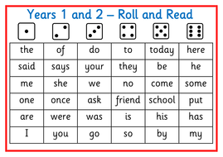
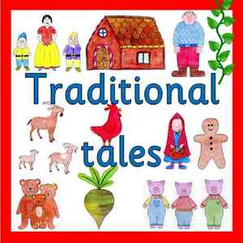
How many traditional tales do you know?
Can you retell a story to your family?
Write or draw a story map of your favourite traditional tale. We look forward to seeing them all.
Clever Counting
https://www.youtube.com/watch?v=vq3cDj3Uj3I

Count in groups of 2, 5, and 10.
Count objects by grouping them in 2s, 5s and 10s.
Count 2p, 5p and 10p coins.

Be great sharing friends
Make equal groups by sharing
Eg. Share muffins, sweets, grapes equally between 2 plates.

Help with the laundry
How many equal groups of 2 can you make using socks or gloves?

https://www.topmarks.co.uk/ordering-and-sequencing/caterpillar-ordering

