Y2 Home Learning
Beech, Lime and Willow Class
- Read at least 3 times a week please initial and or comment in your child’s reading diary each time they read to you.
- Read and spell these words: You could cut them out and make flash cards. We will find out in school how many your child can spell at the end of the term.
behind | half | parents
water | people | busy
clothes | who | many
any | path | poor
plant | pass | grass
climb | hold | sugar
even | hour | sure
gold | improve | whole
eye | move | wild

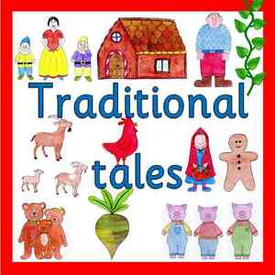
How many traditional tales do you know?
Can you retell a story to your family?
Write or draw a story map of your favourite traditional tale. We look forward to seeing them all.

Continue to practise using money. Adding notes and coins. You could use the game https://www.topmarks.co.uk/money/toy-shop-money

Learn 2x ,5x and 10x tables

