**GIRLS**

Girls were taught at home by their mothers in **Athens**. They were taught how to cook and to look after the home. They rarely left the **Gynaikon** until they reached marrying age (12 or 13). Their father would arrange marriages to men, often in their 30s. When a girl married, she would offer her dolls to the **Goddess Artemis** to show her childhood was over.

In **Sparta**, girls had more freedom and were encouraged to take part in athletics, music, singing and dancing

**BOYS**

Boys were favoured over girls. In **Athens** they lived in the **Gynaikon** until the age of 6 and were trained by their fathers to master different crafts such as fishing or metalwork. At 7, they went to school where they learned music, reading, writing and arithmetic using an **abacus**. They also prepared to be soldiers by running, throwing javelins and wrestling in the **gymnasium**

In **Sparta** boys left home at 7 to be trained for the military. They were not allowed to leave the army until they were 30 years old.

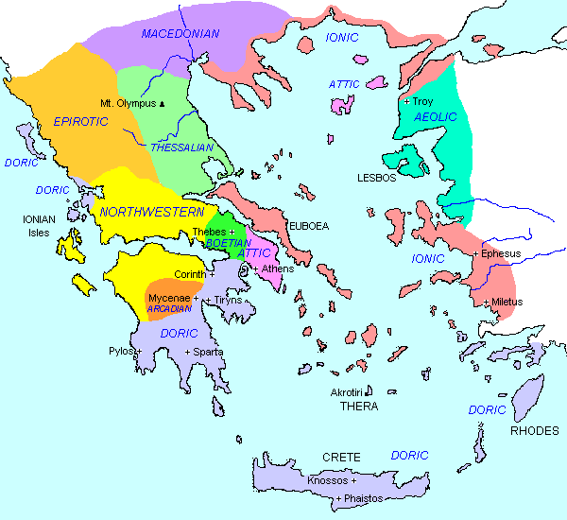

Ancient Greece was made up of lots of **City States** (Polis). The most powerful City States were **Athens** and **Sparta.**

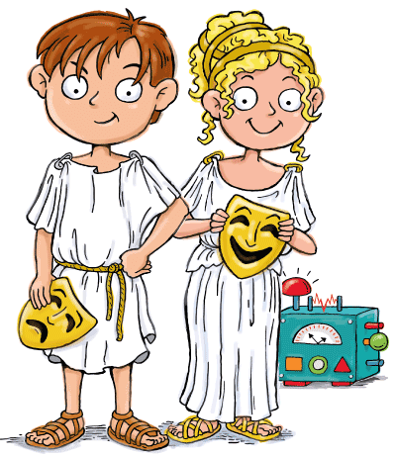

**KEY VOCABULARY** Acropolis Assembly Democracy Helles Gymnasium Gynkainon (women’s quarters) Polis (City State) Oikos (household) Stylus

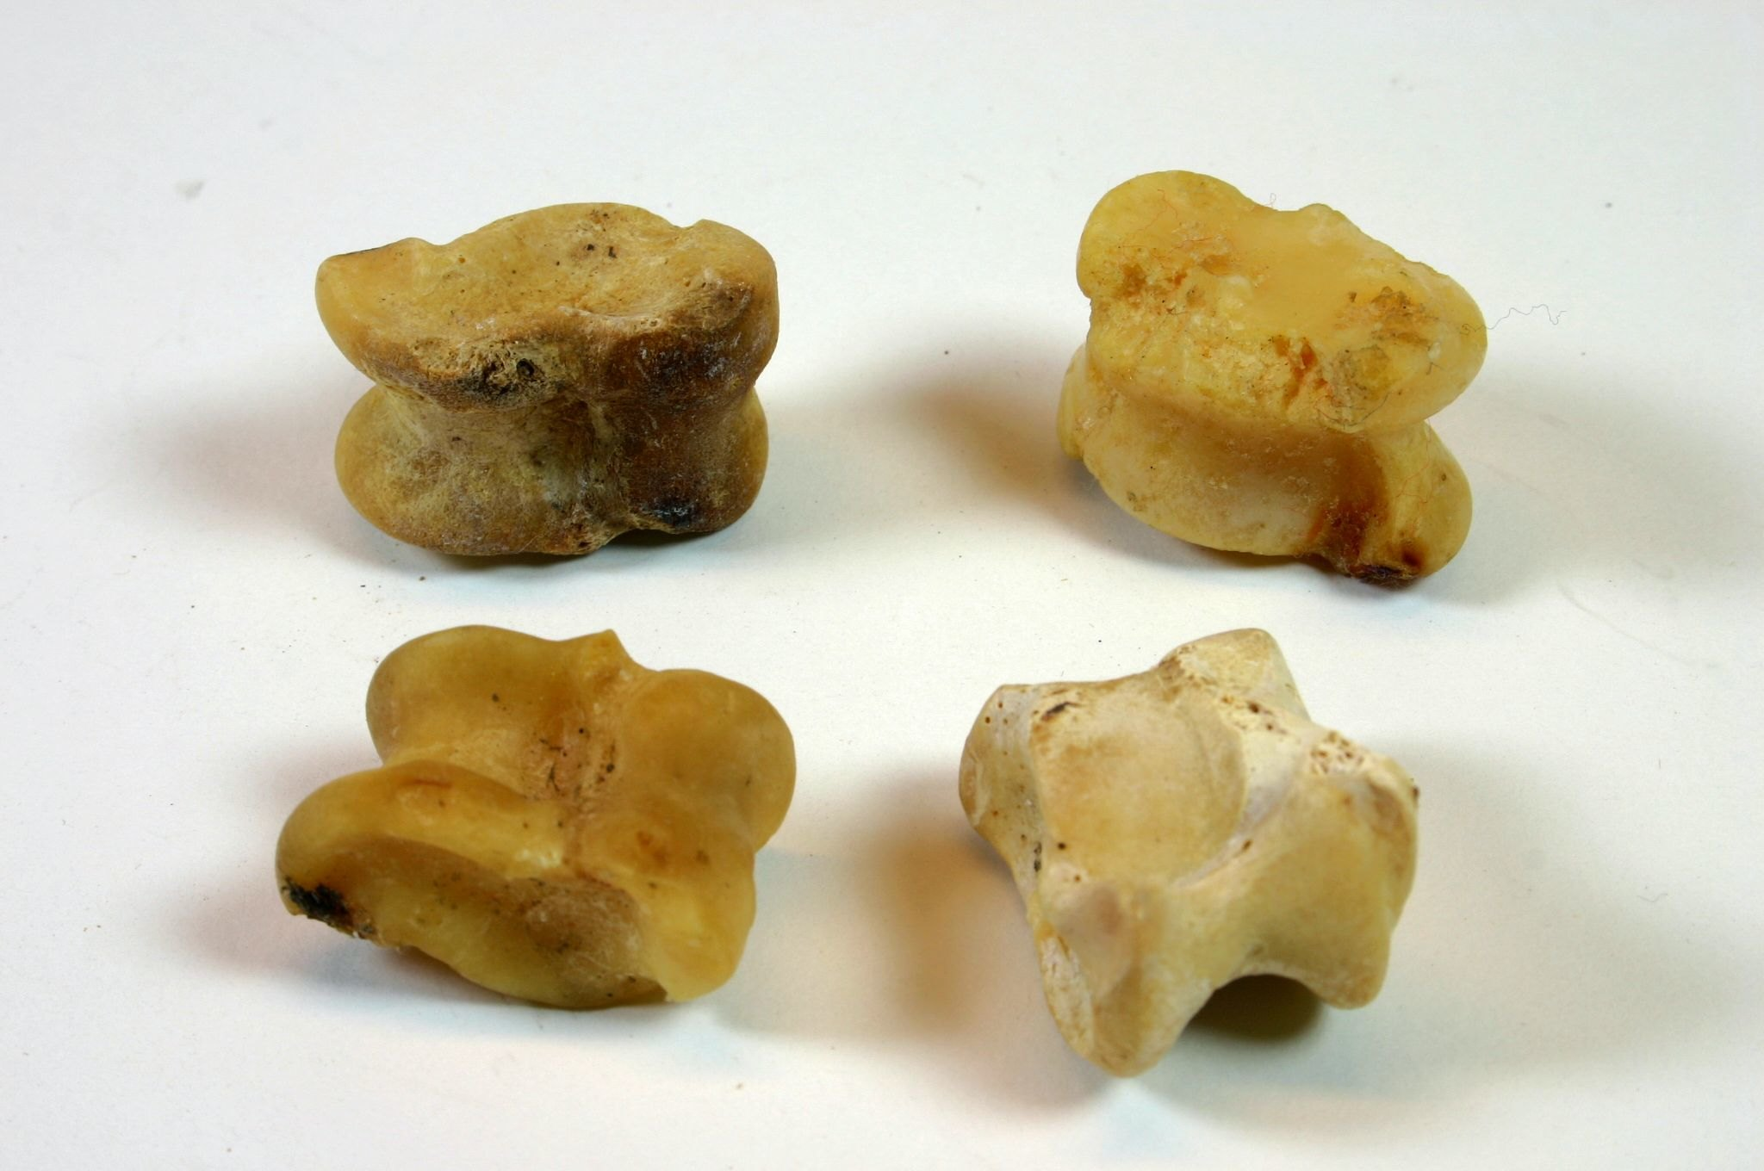

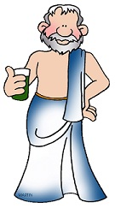

**INFLUENCE ON TODAY** The Ancient Greeks introduced and developed many things that we can recognise today, including:

* The Alphabet
* The Olympic Games
* Democracy
* Poetry
* Philosophy
* Theatre
* Universities (Academia)

**TOYS** **Archaeologists** have found lots of artefacts from Ancient Greece, including toys. Children were usually given toys as gifts on important religious feast days. Toys included:

* Knucklebones made from sheep and goat bones (these were popular and cheap)
* Yo-yos (made from terracotta – a type of clay)
* Marbles (using polished stones, acorns or conkers)
* Dolls made from rags, wax or clay

Richer children had better toys.