Y2 Home Learning
Beech, Lime and Willow Class
- Read 3 times a week.
- Here are all the Year 2 words how many can you read and spell?
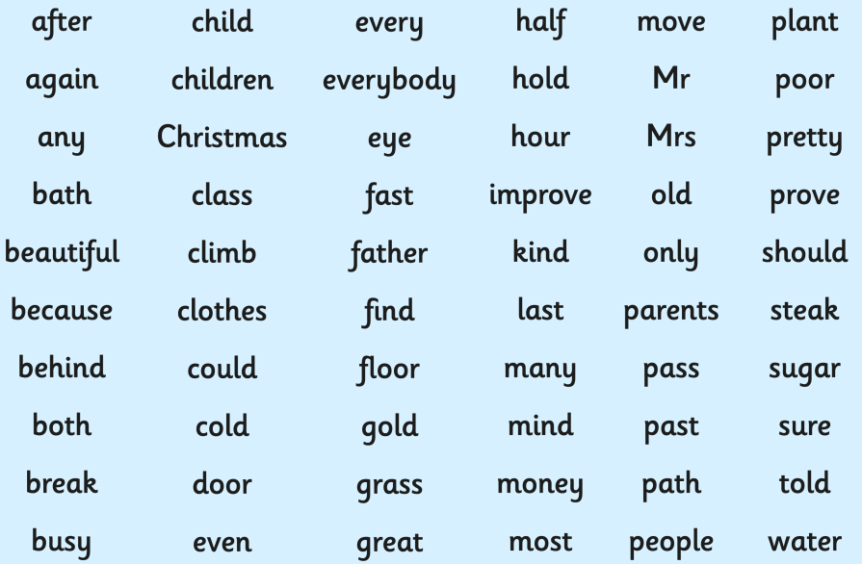
- Be able to read an analogue clock.
- Have a go at following simple recipe and cooking for your family. We would love to see any pictures of your bakes. Xx
- Now we know our number bonds to 10 and 20. Can you use this information to add 2 digit numbers. E.g 26+24=50 18+12=30
10 10
- Have a go at playing this game https://www.topmarks.co.uk/maths-games/hit-the-button

