Totnes Learning Community
Primary Sport Round Up

Wow! What a year! The amount of enthusiastic faces at our sporting events never fails to amaze me! The appetite to take part, compete and have a go combined with the hard work of PLTs has meant that attendance figures for our Learning Community has never been higher! A record breaking year and a massive thank you to all of you for your support! All schools are successfully embedding high quality PE and sport into the daily lives of all our young people and I hope you are seeing benefits across the whole curriculum, as the old adage goes “healthy body, healthy mind!”

Please read on for the highlights of the Summer Term!

KS1 Indoor Athletics Competition
As the new Term swings into action and we turn our attention to the Summer Sports of Athletics, Tennis and Striking and Fielding Games the first of the events involved some of the youngest children in our learning community who came to KEVICC for the KS1 Indoor Athletics Competition. It is important to give those young people who are ready to compete the opportunity to do so as it builds confidence and resiliance which will prove invaluable during their learning journey through school and beyond. Competitors from The Grove, South Brent and Totnes St Johns were competing at maximum levels to achieve their best in a variety of athletics events including hurdles, triple jump, relay, throwing and many more.

Central Venue Basketball League
The basketball league returned this year and proved more popular than ever with 11 teams entering. South Brent brought 4 teams, The Grove brought 3 teams, Broadhemptston brought 2 teams and Totnes St Johns brought 2 teams. After all teams had played each other over 2 evenings it was South Brent who were crowned champions, in fact the South Brent Teams took 3 of the top 4 places in the league which showed that they have been training hard for this during their club sessions!

Primary Football League
The football season reaches its climax with the Playoffs in July. As things stand 3 teams can still win the league so it will go down to the wire at the final CVL date of the year. Who will hold their nerve to emerge as champions this year!

The Grove held their nerve to win it after the final game! Well done to everyone who took part!

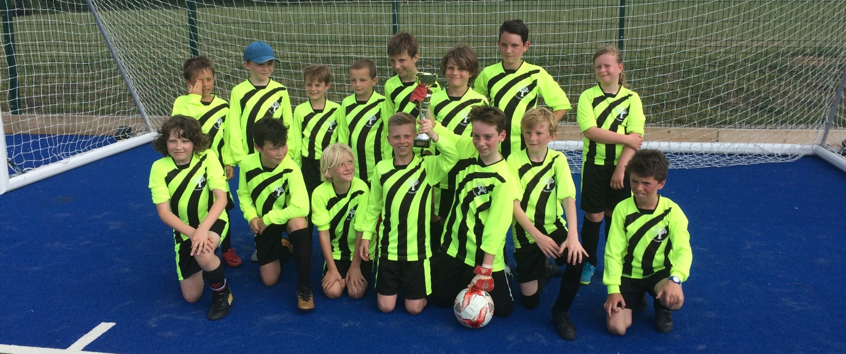

Year 5&6 Dartmoor 3Ball Competition
On a pleasantly overcast but humid June evening the Totnes Learning Community’s Year 5 & 6 Dartmoor 3Ball Competition took place on the Astro. For those who don’t know (and there are quite a few!) Dartmoor 3Ball is a fantastic striking & fielding game which focuses on the whole team participating and being active rather than waiting around which can happen in a lot of the traditionally slow paced striking and fielding games we are used to. The brainchild of a group of SSCO’s the object of the game is to hit 3 balls and then the whole batting team run around to the scoring gates while the whole fielding team try to get the balls back to the bucket person as quickly as possible! It really is a fantastic, action packed game and those who have never played before I urge you so come to one of our competition or festivals to find out more! It will go global eventually I am sure!
7 teams from 5 schools came to compete. After the group stages were completed Landscove faced Dartington in the Final. It was an absolutely breath taking game but in the end Landscove came out winners after some fantastic fielding denied Dartington points in their last few batting attempts. Both teams go on to play at the partnership finals and we wish them the best of luck!

Year 3&4 Dartmoor 3 Ball Competition
On Tuesday 13th June teams from South Brent, The Grove, Totnes St Johns, Landscove, Diptford and Dartington come to KEVICC to battle it out to be Year 3&4 Dartmoor 3Ball Champions. Again the standard of play was exceptional, schools have clearly been practising a lot in prepartion for these competitions! The competition was a league format where all teams had the opportunity to play everyone. When all the points where added up Dartington were top of the league and crowned champions and Landscove, a very close second were awarded the Runners Up spot, the opposite of the Year 5&6 competion and a bit of healthy rivalry is developing between the two schools! Well done to all who took part!

Striking & Fielding Festivals
Over the course of two glorious Summery Friday mornings on 25th May and 8th June over 300 Year 5&6 pupils from The Grove, South Brent, Dartington, Diptford, Landscove, Habertonford and Berry Pomery came to KEVICC to devolp their skills and gameplay in a varity of striking and fielding activitys. The event was expertly planned and delivered by the KEVICC Year 9 and 10 Sports Leaders who did a fantastic job in assisting pupils to improve and appply skills in awide range of disciplines including batting in cricket, fiedling, gameply in rounders and of course introducing our very own Dartmoor 3Ball game!

Change4Life Festival
On a gloriously sunny morning on 22nd May we ran our Change for Life Festival. The theme was based on the upcoming Football World Cup with each school selecting a country that they wanted to represent with many pupils wearing colours of their chosen team, bringing country flags and adorning colourful face paints. The pupils were very fortunate that Arthur the School Games Mascot was able to attend, helping out with the penalty shoot-out and wandering around causing havoc and making the pupils laugh! Children were able to try a wide variety of activities including Cycling, Frisbee, a Penalty Shoot-out, Archery, Problem solving and Boccia. With a carnival atmosphere the event was a great success!

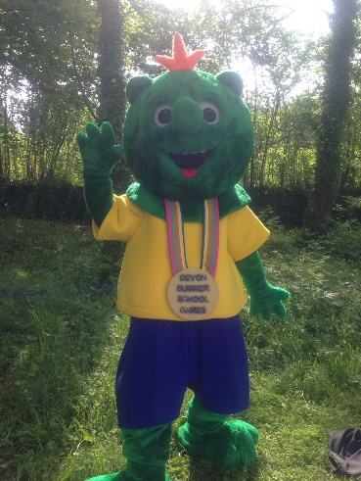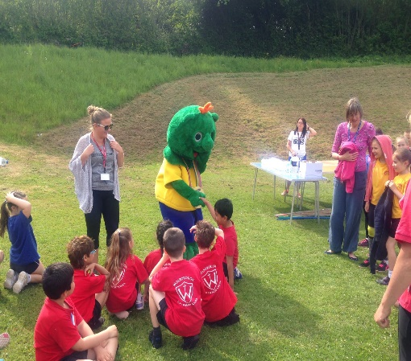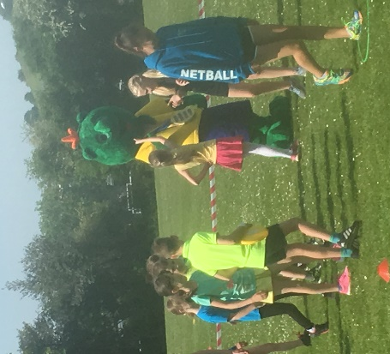

Cross Country
The third and final of the Cross Country Competitions took place on Tuesday 1st May. There was a massive turn out of pupils competing, with 401 competitors from 22 schools taking part in 4 separate races Year 3/4 Girls, Year 3/4 Boys, Year 5/6 Girls and Year 5/6 Boys. It was great to see so many parents and siblings supporting and cheering their children at the finish line, creating a wonderful atmosphere for the pupils as they completed the race.
We changed the start line, from the previous event, so that all races went off from the same place but changed the route so that yr 3/4’s were running a slightly shorter course. However, both were challenging, with a big hill in the middle of the course. A huge thank you needs to be given to the Sports Leader’s who did a fantastic job at supporting the runners and keeping them safe while running through the woods. Also, to Adam Holland (Endurance Athlete and Guiness World Record Holder) who was our Hare!

KS1 Summer Sports Festival The final Key Stage 1 Festival of the academic year on Friday 13th July gave the children the opportunity to have a go at a variety of summer sports including athletics, striking and fielding and net and wall games. The festival was well attended by children from Diptford, The Grove, Landscove, South Brent and Harbertonford.

Thank you!
Can I take this opportunity to thank all staff, parents and children for their efforts this year. Without you all we do not have such a successful School Sport Partnership where all children have the opportunity to participate in such a wide variety of sports and physical activity. I am so proud of what we have achieved this year and I hope you all have a very restful Summer Holiday!

Please take time to look at the events coming up in September!

Upcoming Events in September

Tuesday 11th September Tag Rugby Staff INSET@ SDCC 4-6pm

Wednesday 19th September Primary School Basketball League @KEVICC 4-5:30pm

Monday 24th September Primary School Football League @KEVICC 4-5:30pm

Tuesday 25th September Year 3-6 Cycling @ tbc 4-6pm

