Y1 Home Learning
Beech, Lime and Willow Class
- Read 3 times a week.
- Here are .all the Y1 key words. How many can you read and write?
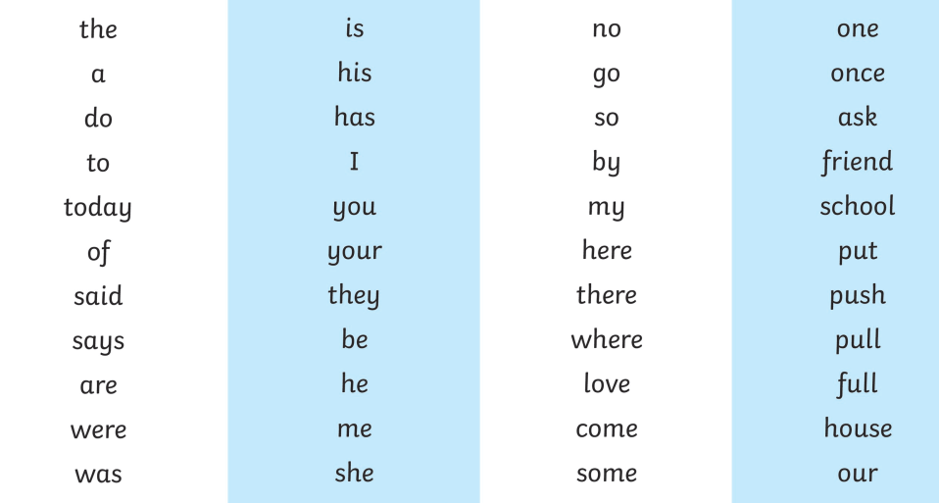
- Practise reading these ‘alien’ words click on the link or visit our class page for the link https://thegrove.eschools.co.uk/cms_manage/edit_page/346694
- Know your number bonds to 20.e.g 1+9=10, 2+8=10, 17+3=20, 16+4=20
0 | 1 | 2
3 | 4 | 5
6 | 7 | 8
9 | 10 | 11
12 | 13 | 14
15 | 16 | 17
18 | 19 | 20

Have a go at following a simple recipe and cooking for your family. We would love to see any pictures of your bakes. xx

