Andalusia – Andalucía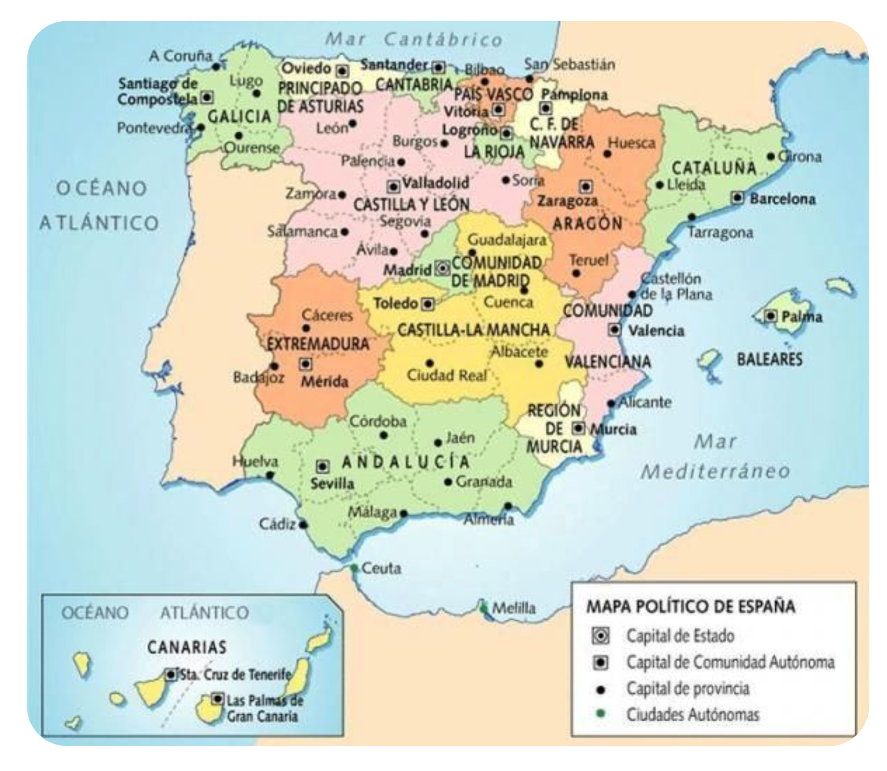
First, a cheerleader style song where you can hear the names of all the regions of Spain shown in capital letters on the map above being sung. Listen and look at the map at the same time! She starts in the top left corner with Galicia and then goes clockwise. Listen again and sing along / pause and repeat!
https://youtu.be/todGWh HacwM

Andalusia – Andalucía
Andalusia is a large region of Southern Spain – can you find it on the map above? It has greatly varying natural beauty, from high snowy mountains where you can ski, to fertile river valleys, to hot bone-dry deserts used for cowboy movies, and long sandy beaches.

Andalusia also has a rich and very much alive cultural heritage – expressed through festivals, food, dance and music, for example – which locals are very proud of and often feel united by.

Andalusia: 2 minute tourist video
https://youtu.be/dTGw9KYx_-E

Dance:
Flamenco:
It’s common for children to learn flamenco, and other traditional dances like Sevillanas. It’s often one of the things that Andalusian people may say is “ours”, and feel hugely passionate about.

Flamenco dancer Rocío Molina when she was only 11 years old; from 5.00 minutes in is very nice.
https://youtu.be/3fHU3gtl3Ew

Flamenco: easy ‘clappy stampy’ 1 minute lesson https://www.youtube.com/watch?v=AsPhnlXehBk

Flamenco: wrist and hand movements
https://www.youtube.com/watch?v=OvgzKH6t_VQ

Flamenco dancer using castañuelas – castanets – while dancing to a piece of guitar music that you may well have heard: 60s band The Doors used this tune (stole?) in their well-known song ‘Spanish Caravan’.
https://www.youtube.com/watch?v=AwcOCgBRZZ4

Sevillana = “From Sevilla”, capital of Andalusia
Sevillanas are a kind of dance and music that may look a lot like flamenco to us, but it’s quite different; particularly the fact that flamenco is much more spontaneous, creative and individual, whereas Sevillanas follow a series of set steps.
https://youtu.be/v_3EiFA37Zw
More info here: https://pura-aventura.com/travel-stories/what-is-the-difference-between-flamenco-and-a-sevillana

Snow, Wetlands, Desert, Beaches …
Compare these different landscapes:

The Sierra Nevada (= “snowy mountains”) of Andalusia: skiing with a sea view on a clear day!
https://www.youtube.com/watch?v=jI2yIaNACf8

Feathered flamencos – flamingos – in Doñana National Park, a wetland haven for these birds. Is there a similarity with the dance moves?
https://www.youtube.com/watch?v=xAOVMrWO9EQ

Also in Andalusia we find Tabernas Desert, which has been the location for many movies that need a desert backdrop: https://www.youtube.com/watch?v=tXkT-Iaukp8

Beach-wise, with 600 miles of coastline Andalusia has lots to choose from. Here are just a few: https://www.youtube.com/watch?v=ACBCwJVd4_s

Food
Some popular Andalusian dishes. What do you fancy?
https://www.costaexcursions.es/day-trips/a-few-reasons-why-andalusia-is-a-paradise-for-food-lovers/
More serious foodie detailed recipe choices here:
https://www.andalucia.org/en/recipes/

Architecture
A few highlights. Which do you like?

- The Romans built different kinds of highly advanced structures all over Spain while they were there for a period of about 600 years around 2,000 years ago; including in Andalusia, many of which survive today: https://blog.playasenator.com/en/roman-monuments-spain/

The Alhambra is a beautiful palace and fortress located in the city of Granada in Andalusia, which was built during the nearly 800 year period of Islamic civilization in Spain from 711 until 1492, along with other architectural treasures.
Short video. https://youtu.be/ZSyfREGVqIQ
More info here: https://www.youtube.com/watch?v=38kmLyWc2iw

Christians in Spain later built many wonderful churches and cathedrals, sometimes adapting previous existing buildings; eg the Cathedral of Cordoba:
https://youtu.be/cZVIC1Pua1o
More info here: https://theculturetrip.com/europe/spain/articles/the-10-most-beautiful-churches-in-spain/

Andalusia has something wonderful for everyone to enjoy.

What would you like to see and do there?

