Year 5/6 Spelling List Spring Term 1st Half Term
Please practise these lists of spellings in your homework book each week, ready for your spelling test on a Wednesday. These are your lists of spellings unless your teacher has given you a different list.

Week 1 Friday 10th January: to be tested on Wednesday 15th January
Homophones and statutory words:
Led, lead, steal, steel, alter, altar, allowed, aloud, bridle, bridal, past, passed, aisle, isle, affect, effect, heard, herd, assent, ascent, knew, new
Sentence, separate, special, straight

Week 2 Friday 17th January: to be tested on Wednesday 22nd January
Building words from root words and statutory words:
Grapheme, graphic, autograph, automatic, phoneme, phonetic, xylophone, microphone, microscope, telescope, television, telegraph, quadrilateral, definite, unhelpfulness, signature, disaster, careful, careless
Strange, strength, suppose, surprise

Week 3 Friday 24th January: to be tested on Wednesday 29th January
Ei and ie words:
Carefelly practise the words in the table. Your teacher will not test you on all of these words but will choose some that follow each pattern and rule.
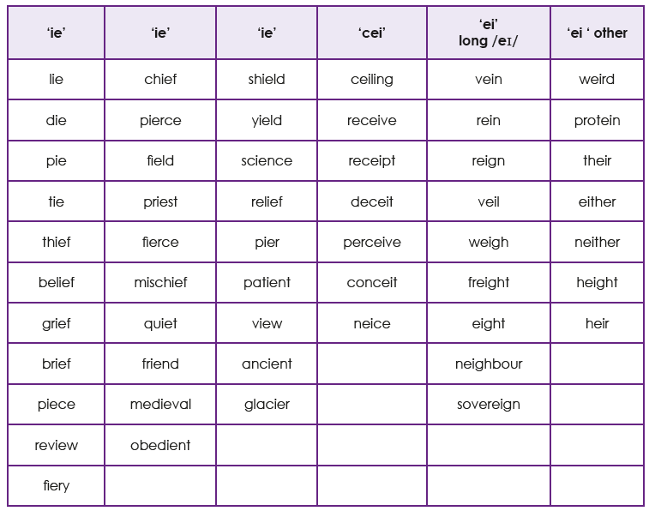

Week 4 Friday 31st January: to be tested on Wednesday 5th February
Proofreading writing and statutory words:
This week we will work on reading through writing and editing it for any incorrect spellings. Practise spotting incorrectly spelt words using the patters and rules we have been working on this year.
Therefore, though, thought, through

Week 5 Friday 7th February: to be tested on Wednesday 12th February
Revision of spelling rules taught and statutory words:
This week we will go over rules you have been taught this year and choose words following these rules. Try to focus on the rules you have found more tricky and specific words you know you find harder. You could always look back on Seesaw to see which you weren’t sure about in previous weeks.
Various, weight, woman, women
.

