Year 5/6 Homework for Autumn half-term
This term the homework will all be online but it is dated so every week there is a different task to hand-in. If you want you can do multiple homeworks in the same week but they will be marked/checked on the hand-in dates. Homeworks will be given out on Fridays and handed in on Wednesdays. Remember to also check your spellings and whether you have any reading tasks to do in your reading diaries.
Task | Hand-in date
Design/Reading:  Task 1: Please decorate your homework book with images and pictures which inspire you.  Task 2: In your reading diaries please write a character description about a character in the book you’re reading at the moment. If you want, add an illustration! If you’d rather not write in sentences then do a drawing of your character and write descriptive adjectives around it to describe them. | 12/09/18
Maths: Please practise your times tables by using times table rockstar login. Record in your homework book which tables you practised and for how long. If you don’t have access to a computer/tablet at home let your teacher know and you can do this as a morning task. | 19/09/18
Handwriting: Log into the Letter Join handwriting app to practise your cursive handwriting at speed. If you don’t have access to a computer/tablet at home let your teacher know and you can do this as a morning task. | 26/09/18
ICT: It is really important that we are all using technology safely! Have a go on the esaftey website: https://www.thinkuknow.co.uk/8_10/  Select the 8-10 category and have a go at the esafety game.  If you don’t have access to a computer/tablet at home let your teacher know and you can do this as a morning task. | 3/10/18
Maths: In year 5 and 6 we have to learn how to work with really big numbers and decimals using column addition. Imagine an alien came to The Grove School. Can you write a step-by-step guide explaining how to add and subtract numbers up to 10,000 and decimals? If you can’t remember, go to the webpage http://www.the-grove-primary.devon.sch.uk/web/policies_and_data_protection/138107 and click on the maths calculation policy. | 10/10/18
SPaG: Select 2 or 3 pages from the SPaG challenge booklet and have a go at the questions in your homework books. The booklet can be found on your class page. | 17/10/18
Topic: Gryffindor, Hufflepuff, Ravenclaw and Slytherin…. All Hogwarts houses with distinctive personalities!  Can you design a new Hogwarts house? What would the emblem be? A fire-breathing dragon? A twinkling unicorn?  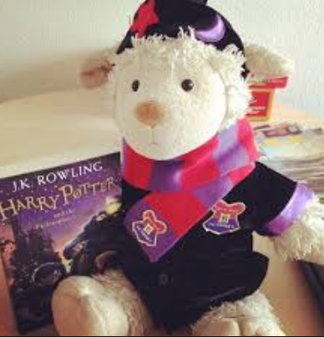  Design a new set of Hogwarts Robes, you can do this in your homework books or for a soft toy. Bring in your ideas for a Hogwarts catwalk competition. | 31/10/18

