3Year 5/6 Home Learning for Autumn 2
Here is the home learning for the second half of the autumn term. There is a different task each week with a date for when it needs to be handed in (always a Wednesday). If you want, you can do all the tasks in one big go! However, they won’t be marked/checked until the hand-in date. Remember to practise your spellings in your home learning book and don’t forget - Dojos and Mash points always on offer for good work!
Task | Hand-in date
Topic: You are heading into the Amazon Rainforest for a 3 day hike. But what to take? Carrying lots of things will be heavy and tiresome, whilst not taking essentials could be dangerous. Your bag should weigh no more than 20kgs. You do not need water, this has already been organised.  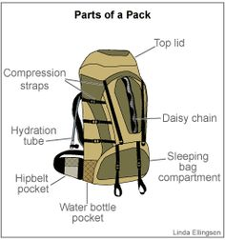  Make a list of things you would take. Show this information in any way you wish. (Don’t forget to include the weights!). | 08/11/19
Maths: Can you use just four 4s and any operations to write the numbers from 0–10.  For example To make the number 3 you could do 4 + 4 + 4 and then divide by 4.  Can you find more than one way of making a number? | 15/11/19
Literacy: When you were hiking in the jungle, you kept a diary. Now a leading magazine would like to publish your diary and share your adventure with the world.  Create a diary entry describing your time hiking through the rainforest. What did you see? What memories stuck with you? How were you feeling? Did you meet anyone? Did you struggle without home comforts?  You could write, type or record your diary (or think even further outside the box to present it!). | 22/11/19
Art: The rainforest is full of weird and wonderful plants –large and small and often colourful. Several provide the basis for mediciines.  You task is to design a new plant and list the features that this plant has. How is it adapted to the rainforest? What benefits does it have? Draw or make your own rainforest plant with annotations or notes to describe \it’s features. Be creative!  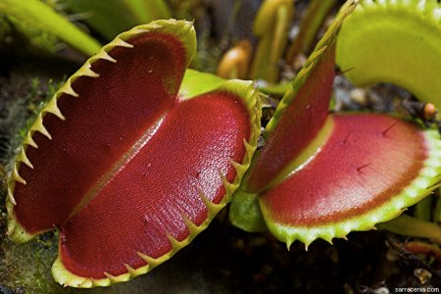 | 29/11/19
Maths: Number Maze Target 100 (below):  Start with zero and make your way through the maze, following the arrows, to the end so that you finish with a total of 100. There are 2 possible routes.  What’s the highest total you can find? What’s the lowest total? | 06/12/19
Christmas! Write a letter to Father Christmas with your present wish list. Using the most persuasive language that you can, explain to Father Christmas (and his elves) why you deserve to have your wishes come true!! | 13/12/19

NUMBER MAZE – TARGET 100
