Year 5/6 Homework for Christmas half-term
This term the homework will all be online but it is dated so every week there is a different task to hand-in. If you want you can do multiple homeworks in the same week but they will be marked/checked on the hand-in dates. Homeworks will be given out on Fridays and handed in on Wednesdays. Remember to also check your spellings and whether you have any reading tasks to do in your reading diaries.
Task | Hand-in date
SPaG  Choose your favourite Harry Potter character. Can you draw them in your homework book and write sentences around them using expanded noun phrases? Remember to challenge yourselves to use the most ambitious adjectives you can!  The adjective, adjective noun with adjective, adjective noun. | 07/11/18
Maths  Write yourself 5 calculations involving multiplying or dividing by 10, 100, 1000, 10,000. When you have worked out the answers can you have a go at writing yourself a word problem for each calculation?  e.g.  567 x 10 =  A farmer ordered 567 litres of fertiliser for his crops, last year he needed 10 times more, how much fertiliser did he need last year? | 14/11/18
Handwriting  Find a passage which you really enjoyed in your Harry Potter book. Write this passage out in your homework books using a handwriting pen and beautiful cursive handwriting. | 21/11/18
SPaG  Write instructions for a magic potion using colons, commas and semicolons. The potion can be to create anything you like: let your imagination run wild! | 28/11/18
Maths:  Fractions! Have a go at the fractions worksheet on your class page. If you’re year 5 have a go at the first section (and the second if you would like!) If you’re year 6 have a go at both sections. | 5/12/18
Topic/Growth Mindset:  2 week project  Having a Growth Mindset encourages us all to be more confident and resilient with our learning. Many successful people had lots of setbacks before succeeding but they kept going because they had a Growth Mindset!  J.K.Rowling was turned away by 12 publishers before Harry Potter was finally published: imagine how different things would have been if she’d given up at the first hurdle!  We would like you to research another famous person who suffered setbacks before becoming successful. You can present your project as a poster, word document, powerpoint: the choice is yours..!  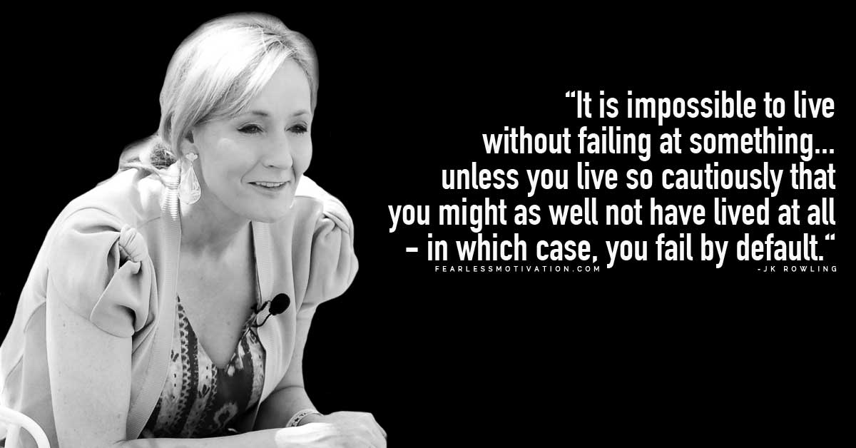 | 19/12/18

