A complete spelling programme
Year 4

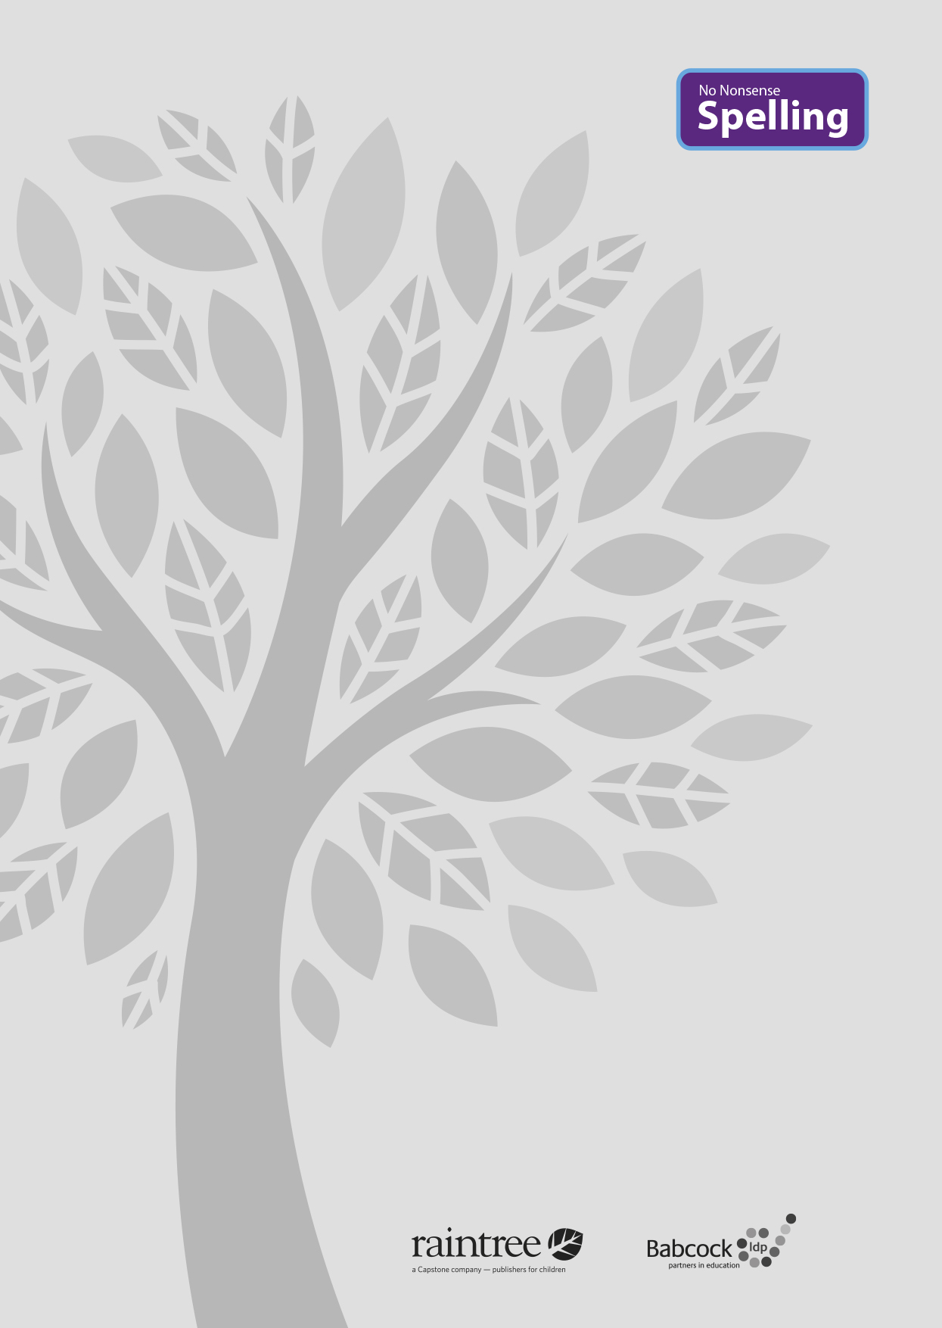

A complete spelling programme
Year 4

Raintree is an imprint of Capstone Global Library Limited, a company incorporated in England and Wales having its registered office at 7 Pilgrim Street, London, EC4V 6LB – Registered company number: 6695582

www.raintree.co.uk
myorders@raintree.co.uk

Text © Capstone Global Library Limited 2016
The moral rights of the proprietor have been asserted.

All rights reserved. No part of this publication may be reproduced in any form or by any means (including photocopying or storing it in any medium by electronic means and whether or not transiently or incidentally to some other use of this publication) without the written permission of the copyright owner, except in accordance with the provisions of the Copyright, Designs and Patents Act 1988 or under the terms of a licence issued by the Copyright Licensing Agency, Saffron House, 6–10 Kirby Street, London EC1N 8TS (www.cla.co.uk). Applications for the copyright owner’s written permission should be addressed to the publisher.

Devised and written by Rebecca Cosgrave, Jenny Core, Joy Simpson and Angela Sykes of the Babcock LDP Primary English Team.
Edited by Clare Lewis
Designed by Richard Parker and HL Studios Picture research by Eric Gohl
Production by Helen McCreath
Originated by Capstone Global Library Ltd Printed at Ashford Colour Press, Gosport, Hants

ISBN 978 1 4747 1000 8
19 18 17 16 15
10 9 8 7 6 5 4 3 2 1

British Library Cataloguing in Publication Data
A full catalogue record for this book is available from the British Library.

Acknowledgements
National Curriculum extract p. 11 © Crown copyright information licensed under the Open Government Licence v3.0.

Cover image provided by Shutterstock

Every effort has been made to contact copyright holders of material reproduced in this book. Any omissions will be rectified in subsequent printings if notice is given to the publisher.

All the Internet addresses (URLs) given in this book were valid at the time of going to press. However, due to the dynamic nature of the Internet, some addresses may have changed, or sites may have changed or ceased to exist since publication. While the author and publisher regret any inconvenience this may cause readers, no responsibility for any such changes can be accepted by either the author or the publisher.

Contents

Introduction 4
What is the No Nonsense Spelling Programme? 4
Assessment 6
Complementary Resources 7
Learning Spellings 9

Year 4 National Curriculum requirements 12

Year 4 Lesson plans 13
Year 4 Term 1 overview 13
Block 1 – autumn first half term 15
Block 2 – autumn second half term 21
Year 4 Term 2 overview 26
Block 3 – spring first half term 28
Block 4 – spring second half term 34
Year 4 Term 3 overview 40
Block 3 – summer first half term 42
Block 4 – summer second half term 47

Statutory word list for Years 3 and 4 52
Year 2 Supporting Resources 53

Introduction

What is the No Nonsense Spelling Programme?

The No Nonsense Spelling Programme was devised to offer teachers a comprehensive yet accessible progression in the teaching of spelling. Guidance, rather than prescription, is provided on how to teach the strategies, knowledge and skills pupils need to learn.

The focus of the programme is on the teaching of spelling, which embraces knowledge of spell- ing conventions – patterns and rules; but integral to the teaching is the opportunity to promote the learning of spellings, including statutory words, common exceptions and personal spellings.

The programme

- delivers a manageable tool for meeting the requirements of the 2014 National Curriculum
- has a clear progression through blocks of teaching units across the year
- comprehensively explains how to teach spelling effectively.

How No Nonsense Spelling is organised

The programme consists of the following elements:

- The requirements of the National Curriculum, which have been organised into strands and then broken down into termly overviews. The overall pathway can be found on the USB stick.
- Termly overviews that have been mapped across weeks as half termly plans. These follow a
model of five spelling sessions across two weeks, except in Year 2 where sessions are daily.
- Daily lesson plans for each session, with Supporting Resources, including word lists and guidance on conventions.

The lesson plans

The lessons themselves then follow the structure below:

Lesson | Reference to year group, block of lessons and lesson number in sequence
Lesson type | Revise/Teach/Learn/Practise/Apply/Assess
Lesson focus | The particular spelling focus for the day
Resources needed | A list of the resources that will be needed. These might be documents that are photocopied or printed in advance so that flashcards can be prepared, or presentations to display the task/activity on a whiteboard. The resources are featured at the end of each book for reference. Editable versions are available on the USB stick, which can be copied and pasted into your own documents and edited.
Teaching activity | Key teaching points, sometimes including extra notes and tips for the teacher

4

Each lesson is approximately 10 to15 minutes long, but lesson plans are flexible so that the teaching can reflect the extra time needed on a teaching point if required. The Supporting Re- sources at the back of each book can be used as appropriate to adjust the pace and focus of the lesson. Each lesson clearly signposts when additional resources from the Programme can be used.

Supporting Resources

The Supporting Resources include pictures and word lists, which can be photocopied and made into flashcards or used in classroom displays, and pictures. They also include games and quiz- zes. The Resources are featured at the end of each book for reference and as editable Word documents on the USB stick, which can be copied and pasted to be used on classroom white- boards and in other documents.

Teaching sequence
The programme has been written broadly following a teaching sequence for spelling, whereby each new concept is taught, practised and then applied and assessed. Frequently there is also a ‘Revise’ session before the teaching session. A typical teaching sequence is as follows:

Revise
Activate prior knowledge Revisit previous linked learning

Teach
Introduce the new concept Explain
Investigate Model

Practise Individual/group work
Extend/explore the concept independently Investigate
Generalise

Apply/Assess
Assess through independent application Explain and demonstrate understanding

Within the lessons, the particular focus is identified, followed by suggested teaching strategies. By integrating activities for handwriting, the benefit of making a spelling activity kinaesthetic is
secured. The pupil acquires the physical memory of the spelling pattern as well as the visual. Integral to the process is the scope to encourage pupils to learn spellings. The value of a school policy and possible approaches are explored further on page 9, ‘Learning spellings’.

You will find the following referred to in the lessons:
Modelling: An activity is described, and it is anticipated that the action expected of pupils is mod-
elled to them first.
Spelling partners: Pupils are asked to work in pairs, often to ‘test’ each other. They will be asked to work with their spelling partner from time to time.

5

Assessment

Pupils’ learning is assessed throughout the programme. The ‘Apply’ part of the sequence regu- larly includes assessment activities to identify if pupils have learnt the key concept taught. These activities include:

- Testing – by teacher and peers
- Dictation
- Explaining
- Independent application in writing
- Frequent learning and testing of statutory and personal words.

Error Analysis

Error Analysis can be used to assess what strategies pupils are using in their day-to-day writing. It can also help identify where to put emphasis in the programme – for the whole class, groups or individuals. Error Analysis can also be repeated to assess progress over a longer period of time.
A template for a suggested grid for Error Analysis can be found in the Supporting Resources. How to complete an Error Analysis:
- Choose one piece of independent writing from each pupil.
- Identify all the spelling errors and record them on the grid. Decide what you think is the main source of the error and record the word in the corresponding column. It is a good idea to re- cord the word as the pupil has spelt it.
- Identify any patterns. Quite quickly you will be able to see which aspect of spelling needs to be addressed.

The headings on the grid included are

- Common exception words
- GPCs (grapheme–phoneme correspondences) including rarer GPCs and vowel digraphs
- Homophones
- Prefixes and suffixes
- Word endings
- Other.

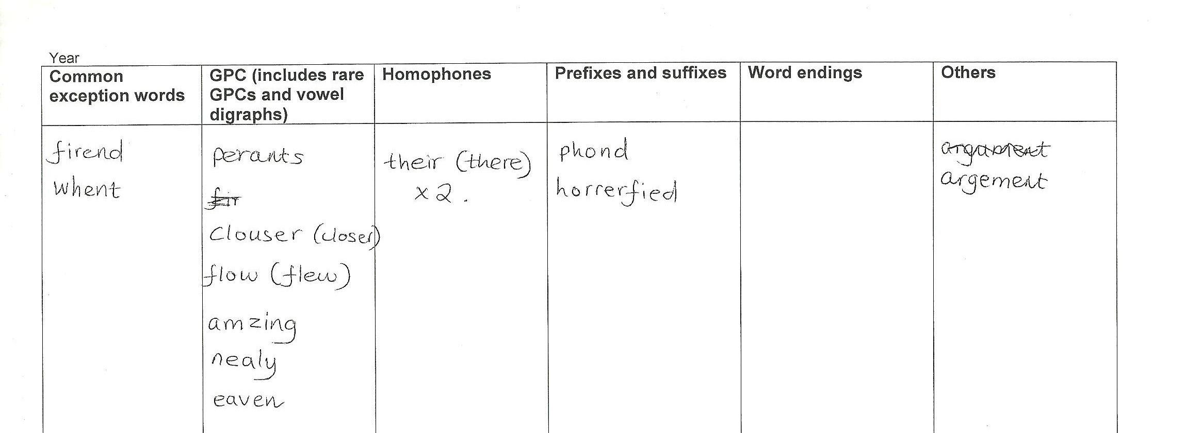
These headings correspond to key strands within the National Curriculum. These could be changed or further areas added if needed.

6

Complementary resources

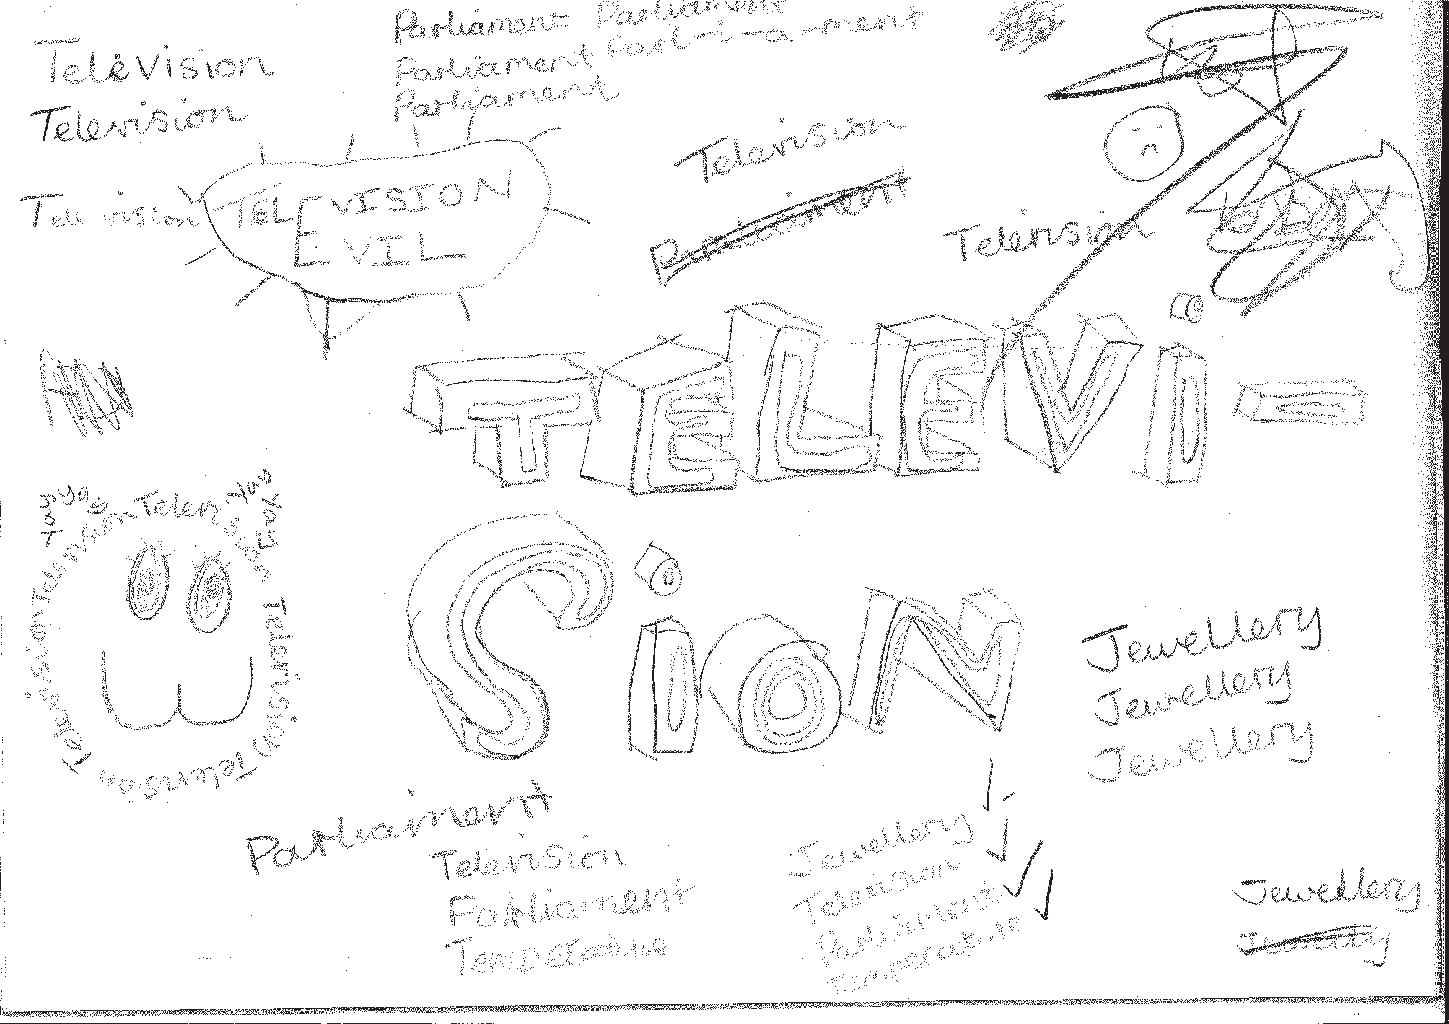
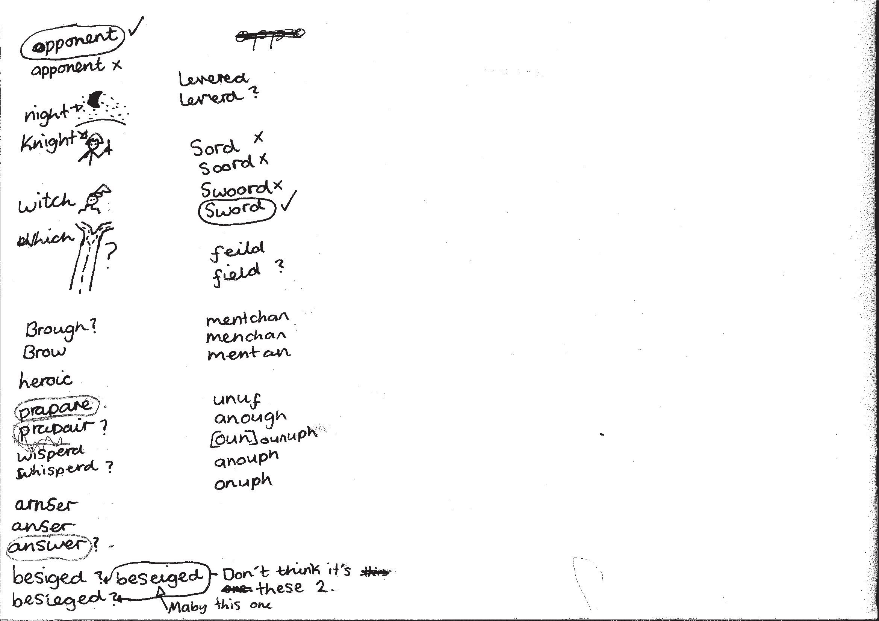
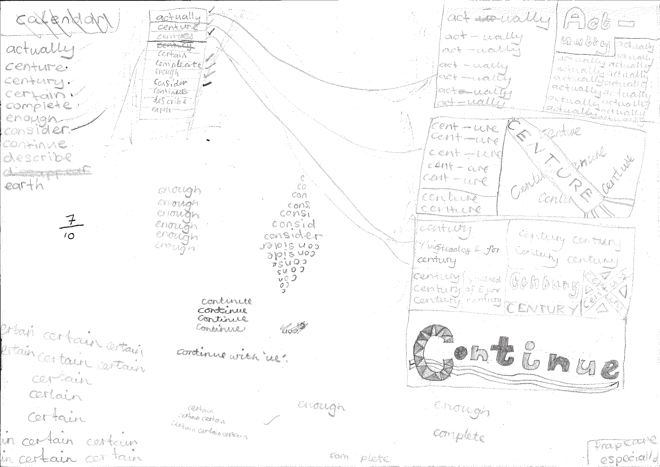
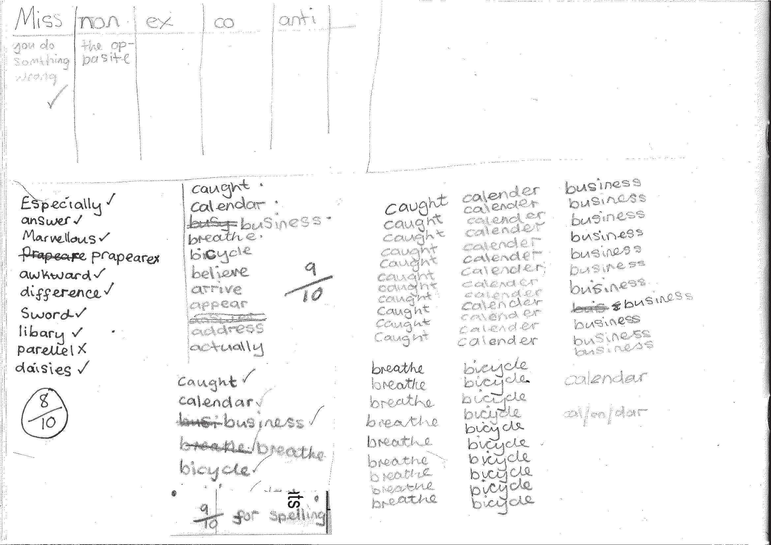
To support the teaching, additional resources are recommended and referred to throughout the programme.

Developing the use of spelling journals can support both teachers and pupils in many ways. They enable

  - pupils to take responsibility for their spelling learning
  - pupils to refer back to previous learning
  - teachers to see how pupils are tackling tricky bits of spelling
  - teachers and pupils to discuss spelling with parents and carers

Spelling journals
Spelling journals can take many forms and are much more than just a word book. Spelling journals can be used for

- practising strategies
- learning words
- recording rules/conventions/generalisations as an aide-memoire
- word lists of really tricky words (spelling enemies)
- ‘Having a go’ at the point of writing
- ongoing record of statutory words learnt
- investigations
- recording spelling targets or goals
- spelling tests.

In the programme, there is flexibility for journals to be set up in a variety of ways. Below are a few recommendations:

- Make sure that the journal can be used flexibly. A blank exercise book gives much more scope for pupils to try out ideas
and organise their learning than a heavily structured format.
- Model different ways of using the journal.
A class spelling journal or examples from different pupils could be used to do this.
- Give time for pupils to use their journals and to review them.
- Do the majority of spelling work in the journal.

7

Have a go sheets | These are a key component of Strategies at the point of writing. They are introduced in the Year 2 programme and then revisited in Years 3, 4, 5 and  6. Schools need to decide how Have a go will form part of their spelling policy, together with the use of spelling journals and establishing routines for attempting unknown spellings. A Have a go sheet template is provided in the Supporting Resources.  Have a go sheets can take several different forms, for example:  - a large sheet of paper on a table that pupils write on when they need to.  - sheets stuck in all pupils’ books that fold out when pupils are writing  - a book placed on the table open at a clean sheet for pupils to use.  - a page in pupils’ spelling journals.  Note: it is important that teachers have an enlarged version of a Have a go sheet displayed for modelling when writing in any curriculum area and at any time in the school day.  Introducing Have a Go:  - Model writing a sentence and being unsure about how to spell a word. Talk about the tricky part in the word and some of the choices you might have for that part. You could refer to a GPC chart to find the choices if appropriate.  - Model writing the word with two or three choices on your own enlarged version of a Have a go sheet and then model choosing the one that you think looks right and using it in your sentence. It is important that pupils learn to ask themselves the question ‘Does it look right?’ or ‘Have I seen it like this in a book?’ to help them make their choices.  - If you are still unsure of the spelling, put a wiggly line under it in the sentence to signal that this needs checking by the teacher, or the pupil if appropriate, during proofreading time.  - Model continuing with writing and not checking the correct version of the spelling at this point. This is important so that the flow of writing is not unnecessarily slowed.  5. Make sure you model this process briefly in writing in all curriculum areas.  - Pupils use their own Have a Go sheet (or group sheet) whenever they write and refer to GPC charts and other classroom displays as support, as well as specific strategies that have been taught for using at the point of writing.  - Remind them never to make more than three attempts at a word.  Misspelt words will need to be corrected in line with your school’s spelling and marking policy. Some of these words may be included in pupils’ individual word lists for learning.  To see lessons where Have a go strategies are first introduced, please refer to  Year 2 Block 1 Lessons 11 and 17.
GPC (grapheme- phoneme correspondence) choices chart | The teaching of spelling complements very much the teaching of phonics. It is anticipated that the school will draw upon the GPC charts used in their phonics programme to work alongside the teaching of spelling.

Individual whiteboards | Individual whiteboards these can be used in a variety of ways to support lessons including checking spelling attempts, Quickwrite and Have a go.
Working wall | It is really useful to have a small area of display space in the classroom that can reflect current teaching focuses and provide support for pupils’ spelling as they write. GPC charts, reminders of common spelling patterns or conventions and tricky words to remember could be part of a working wall for spelling.

Learning spellings

A school policy can help inform

- the strategies for learning spellings that are being taught
- routines for learning spellings
- links with home learning.

Learning needs to happen in school and at home. There is little evidence, though, that the tradi- tional practice of learning spellings (usually 10) at home and being tested on them (usually on a Friday) is effective. However, there is a high expectation within the new National Curriculum that pupils will learn many increasingly complex words. Within the programme, learning spellings is built into each six-week block. Within the sessions a range of strategies for learning spellings are introduced and practised. This enables pupils to choose the strategies they find most effective for learning different words.

Tips for learning spellings at home

Learning at home needs to be an extension of the practice in school. Consider

- limiting the number of words to five or less a week to ensure success and enable deeper
learning
- making sure pupils and parents have access to the range of learning strategies which have been taught in school, to use in home learning
- assessing spellings in context, for example: learning spellings in a given sentence, generating sentences for each word, assessing through unseen dictated sentences
- keeping an ongoing record of words learnt and setting very high expectations of correct application in writing once a word has been learned.

The learning strategies on the next two pages are introduced incrementally throughout the pro- gramme and can then be used to support learning spellings at home.

9

Look, say, cover, write, check | This is probably the most common strategy used to learn spellings.  Look: first look at the whole word carefully and if there is one part of the word that is difficult, look at that part in more detail.  Say: say the word as you look at it, using different ways of pronouncing it if that will make it more memorable.  Cover: cover the word.  Write: write the word from memory, saying the word as you do so.  Check: Have you got it right? If yes, try writing it again and again! If not, start again – look, say, cover, write, check.
Trace, copy and replicate  (and then check) | This is a similar learning process to ‘look, say, cover, write, check’ but is about developing automaticity and muscle memory.  Write the word out on a sheet of paper ensuring that it is spelt correctly and it is large enough to trace over. Trace over the word and say it at the same time. Move next to the word you have just written and write it out as you say it. Turn the page over and write the word as you say it, and then check that you have spelt it correctly.  If this is easy, do the same process for two different words at the same time. Once you have written all your words this way and feel confident, miss out the tracing and copying or the tracing alone and just write the words.
Segmentation strategy | The splitting of a word into its constituent phonemes in the correct order to support spelling.
Quickwrite | Writing the words linked to the teaching focus with speed and fluency. The aim  is to write as many words as possible within a time constraint.  Pupils can write words provided by the teacher or generate their own examples. For example, in two minutes write as many words as possible with the /iː/ phoneme.  This can be turned into a variety of competitive games including working in teams and developing relay race approaches.
Drawing around the word to show the shape | Draw around the words making a clear distinction in size where there are ascenders and descenders. Look carefully at the shape of the word and the letters in each box. Now try to write the word making sure that you get the same shape.

10

Drawing an image around the word | This strategy is all about making a word memorable. It links to meaning in order to try to make the spelling noticeable.  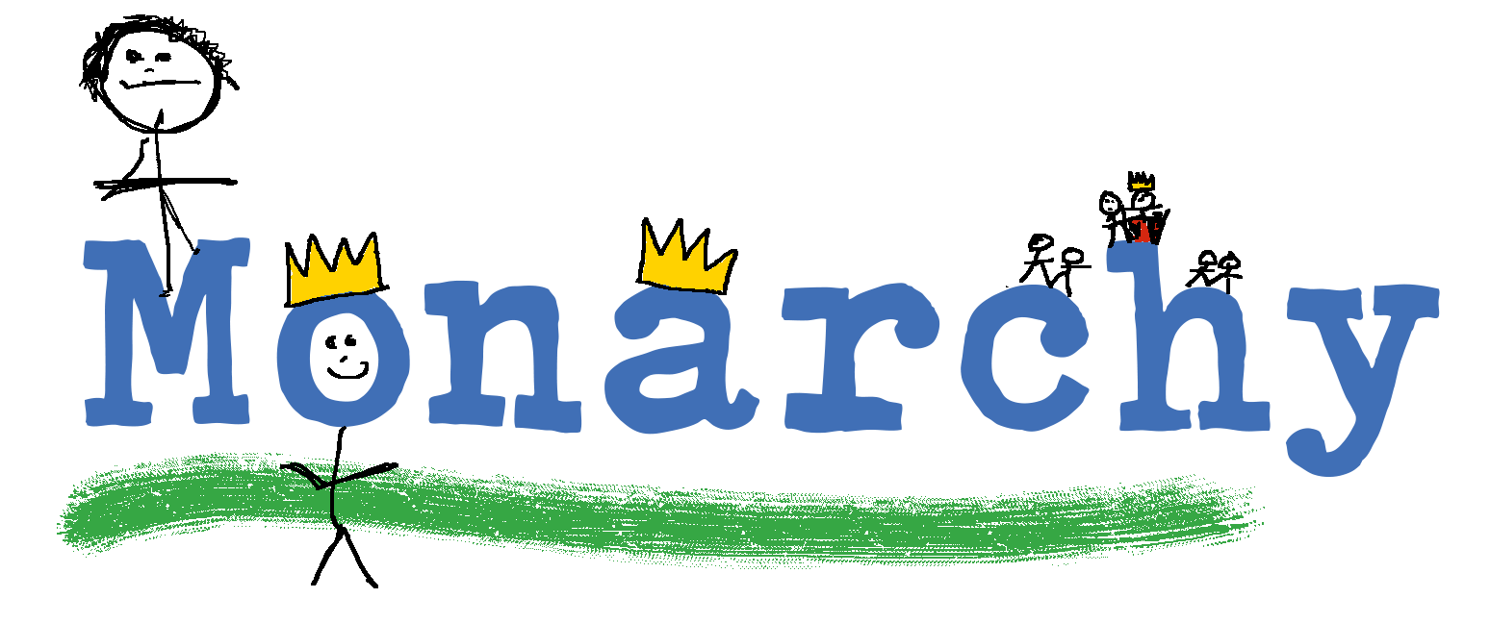  You can’t use this method as your main method of learning spellings, but it  might work on those that are just a little more difficult to remember.
Words without vowels | This strategy is useful where the vowel choices are the challenge in the words. Write the words without the vowels and pupils have to choose the correct grapheme to put in the space. For example, for the word field:
Pyramid words | This method of learning words forces you to think of each letter separately.  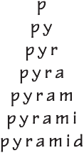  You can then reverse the process so that you end up with a diamond.
Other strategies | Other methods can include:  - Rainbow writing. Using coloured pencils in different ways can help to make parts of words memorable. You could highlight the tricky part s of the word or write the tricky part in a different colour. You could also write each letter in a different colour, or write the word in red, then overlay in orange, yellow and so on.  - Making up memorable ‘silly sentences’ containing the word  - Saying the word in a funny way – for example, pronouncing the ‘silent’ letters in a word  - Clapping and counting to identify the syllables in a word.

11

Year 4 National Curriculum requirements

Pupils should be taught to

  - develop a range of personal strategies for learning new and irregular words*
  - develop a range of personal strategies for spelling at the point of composition*
  - develop a range of strategies for checking and proofreading spellings after writing*
  - use further prefixes and suffixes and understand how to add them (English Appendix 1)
  - spell further homophones
  - spell words that are often misspelt (English Appendix 1)
  - place the possessive apostrophe accurately in words with regular plurals (for example, girls’, boys’) and in words with irregular plurals (for example, children’s)
  - use the first two or three letters of a word to check its spelling in a dictionary
  - write from memory simple sentences, dictated by the teacher, that include words and punctuation taught so far
  - proofread for spelling errors.

* non-statutory

12

Year 4 lesson plans

Year 4 Term 1 overview

Block 1 – autumn first half term

Week 1 | Lesson 1 Revise  Strategies at the point of writing: Have a go | Lesson 2 Learn/Practise Strategies for learning words: words from statutory spelling list | Lesson 3 Assess  Words from statutory and personal spelling lists
Week 2 | Lesson 4 Teach  Words ending /ʒə/ | Lesson 5 Practise  Words ending /ʒə/
Week 3 | Lesson 6 Assess  Words ending /ʒə/ | Lesson 7 Learn  Strategies for learning words: words from statutory and personal spelling lists | Lesson 8 Teach  From Year 2: possessive apostrophe with singular proper nouns
Week 4 | Lesson 9 Practise  From Year 2: possessive apostrophe with singular proper nouns | Lesson 10 Teach Homophones  (peace/piece, main/mane, fair/fare)
Week 5 | Lesson 11 Practise Homophones  (peace/piece, main/mane, fair/fare) | Lesson 12 Apply  Strategies for learning words: homophones (peace/piece, main/mane, fair/fare) | Lesson 13 Learn  Strategies for learning words: words from statutory and personal spelling lists
Week 6 | Lesson 14 Practise  Strategies for learning words: words from statutory and personal spelling lists | Lesson 15 Assess  Words from statutory and personal spelling lists: pair testing

13

Block 2 – autumn second half term

Week 1 | Lesson 1 Revise  Strategies for learning words: words from statutory list learnt previously  Strategies at the point of writing: Have a go | Lesson 2 Revise  Strategies for learning words: words from statutory list learnt previously  Strategies at the point of writing: Have a go | Lesson 3 Teach Proofreading
Week 2 | Lesson 4 Teach  Prefixes ‘in-’, ‘il-’, ‘im-’ and ‘ir-’ | Lesson 5 Practise  Prefixes ‘in-’, ‘il-’, ‘im-’ and ‘ir-’
Week 3 | Lesson 6 Apply  Prefixes ‘in-’, ‘il-’, ‘im-’ and ‘ir-’ | Lesson 7 Learn  Strategies for learning words: words from statutory and personal spelling lists | Lesson 8 Assess  Words from statutory and personal spelling lists: pair testing
Week 4 | Lesson 9 Revise  Words with the /eɪ/ sound spelt ‘ei’, ‘eigh’ or ‘ey’ Words with the /ʃ/ sound spelt ‘ch’ and the /ʌ/ sound spelt ‘ou’ | Lesson 10 Practise/Apply  Words with the /eɪ/ sound spelt ‘ei’, ‘eigh’ or ‘ey’ Words with the /ʃ/ sound spelt ‘ch’ and the /ʌ/ sound spelt ‘ou’
Week 5 | Lesson 11 Learn  Strategies for learning words: words from statutory and personal spelling lists | Lesson 12 Assess  Words from statutory and personal spelling lists: pair testing
Week 6 | Lesson 13 Teach  Adding suffixes beginning with vowel letters to words of more than one syllable (‘-ing’, ‘-er’, ‘-en’, ‘-ed’) | Lesson 14 Practise  Adding suffixes beginning with vowel letters to words of more than one syllable (‘-ing’, ‘-er’, ‘-en’, ‘-ed’) | Lesson 15 Apply  Adding suffixes beginning with vowel letters to words of more than one syllable (‘-ing’, ‘-er’, ‘-en’, ‘-ed’)

14

Block 1 – autumn first half term

Lesson | Year 4, block 1, lesson 1
Lesson type | Revise
Lesson focus | Strategies at the point of writing: Have a go
Resources needed | Supporting Resource 4.2 (Have a go template)
Teaching activity | Model writing using a Have a go sheet (see Introduction page 8) and remind pupils of the strategies you might use to spell the word you want. Remind them that they should only make two or three attempts at spelling before choosing the one they think looks right.  If they are not sure they have the correct spelling, they should draw a line under the word in their writing to alert you to this fact.

Lesson | Year 4, block 1, lesson 2
Lesson type | Learn/Practise
Lesson focus | Strategies for learning words: words from statutory list
Resources needed | Supporting Resource 4.2 (Have a go template) Statutory word list for Years 3 and 4 (page 52)
Teaching activity | Select spellings for each pupil from the statutory list for pupils to learn. Below is a list of strategies that can be used with spellings:  - Segmenting words into phonemes and selecting the correct graphemes  - Segmenting words into syllables  - Visual strategies, for example, recognising common letter strings and checking whether word looks right  - Building words from other words with similar patterns and meanings; applying knowledge of derivations, for example medical, medicine  - Spelling by analogy with other known words, for example, light, fright  - Building words from morphemes, the smallest units of meaning, for example,  prefixes and suffixes: un-usual-ly; exploring morphemes within words  - Applying knowledge of spelling rules and exceptions  - Mnemonics  Words not spelt correctly can form part of the personal list of spellings. Pupils can use their Have a go sheets for writing across the curriculum. This  does not have to be a spelling session unless you need to follow up an aspect of their use.

15

Block 1 – autumn first half term

Lesson | Year 4, block 1, lesson 3
Lesson type | Assess
Lesson focus | Words from statutory and personal spelling lists
Resources needed | Statutory word list for Years 3 and 4 (page 52), personal spelling lists, spelling journals
Teaching activity | Test pupils on the words from the statutory list that they learnt last year.  Identify those that need further learning. If appropriate, add some spellings from personal lists.  Ask pupils to explain the methods that they have for learning spellings and which is most useful when:  - Pyramid words  - Identifying the tricky part of the word  - Trace, copy, replicate  - Look, say, cover, write, check  - Drawing around the word to show the shape  - Drawing a mnemonic around the word  Pupils learn at least five words from the statutory list and some from their  personal list.  Send words home for further learning.

Lesson | Year 4, block 1, lesson 4
Lesson type | Teach
Lesson focus | Words ending /ʒə/
Resources needed | Supporting Resource 4.4 (word cards: treasure, measure, pleasure, enclosure, closure), spelling journals
Teaching activity | Read out the words from the word cards. What do the pupils notice about the words?  Show pupils how the /ʒə/ part is written ‘sure’. Look at treasure, measure and  pleasure. What else is common about those words and how they are spelt?  Practise handwriting of ‘sure’ and ‘ea’.  Ask pupils to try to spell treasure, measure and pleasure in their spelling journals.

16

Block 1 – autumn first half term

Lesson | Year 4, block 1, lesson 5
Lesson type | Practise
Lesson focus | Words ending /ʒə/
Resources needed | Spelling journals
Teaching activity | Pupils create sentences around the words from the last session and write them in their journals.

Lesson | Year 4, block 1, lesson 6
Lesson type | Assess
Lesson focus | Words ending /ʒə/
Resources needed | Spelling journals
Teaching activity | Revise pair-testing routines.  Pair the pupils up and ask them to test each other with their list of words they have learned in the previous session.  They take it in turns to mark each other’s work.

Lesson | Year 4, block 1, lesson 7
Lesson type | Learn
Lesson focus | Strategies for learning words: words from statutory and personal spelling lists
Resources needed | Statutory word list for Years 3 and 4 (page 52), personal spelling lists
Teaching activity | Pupils choose the method most appropriate from the different ways in which they can learn words:  - Pyramid words  - Identifying the tricky part of the word  - Trace, copy, replicate  - Look, say, cover, write, check  - Drawing around the word to show the shape  - Drawing a mnemonic around the word  Pupils learn the words and take them home for further practice.

17

Block 1 – autumn first half term

Lesson | Year 4, block 1, lesson 8
Lesson type | Teach
Lesson focus | From Year 2: possessive apostrophe with singular proper nouns
Resources needed | Spelling journals
Teaching activity | Pupils share what they know about apostrophe use for contractions. Explain that apostrophes can be used for another reason: to show that something belongs to someone.  Collect a range of objects that pupils recognise as belonging to one class member.  Hold the item up and say ‘Whose pencil case is this?’ The class responds with ‘It’s Joe’s pencil case.’  Write the sentence on the board and talk about where you are putting the apostrophe.  Try a couple more examples and then go back to one you have done before, say it again and ask the class to write it in their spelling journals.  Check where they have put the apostrophe.

Lesson | Year 4, block 1, lesson 9
Lesson type | Practise
Lesson focus | From Year 2: possessive apostrophe with singular proper nouns
Resources needed | Supporting Resource 4.5 (possessive apostrophe cards)
Teaching activity | Revise what pupils learnt last session.  Write Cyprus on the board and ask them what happens if the noun ends in ‘s’. Model adding the apostrophe + ‘s’ after the ‘s’.  In pairs pupils divide cards into names and objects.  They shuffle each group, turn one over from each group and then write the  phrase down using the apostrophe correctly, for example Sandra’s football.

18

Block 1 – autumn first half term

Lesson | Year 4, block 1, lesson 10
Lesson type | Teach
Lesson focus | Homophones (peace/piece, main/mane, fair/fare)
Resources needed | Supporting Resource 4.6 (homophone cards)
Teaching activity | Look at the homophone cards and discuss what the words mean and how this might help decide the spelling.  You can introduce fun ways of remembering spellings, such as  There is a piece of pie in the word piece.  Pupils make up mnemonics or draw around the word to help remember the different meanings.  Read out the sentences below and ask pupils to hold up the correct card for the homophone in the sentence.  It’s not fair!  The lion’s mane was old and tatty. I want some peace and quiet.  This is the main road through town. I paid my fare for the bus ride.  Do you want a piece of cake?

Lesson | Year 4, block 1, lesson 11
Lesson type | Practise
Lesson focus | Homophones
Resources needed | Supporting Resource 4.6 (homophone cards) spelling journals
Teaching activity | Pupils work in pairs using the homophone cards.  They take turns to hold up a card and orally compose a sentence that includes it. They write the sentences in their spelling journals.

Lesson | Year 4, block 1, lesson 12
Lesson type | Apply
Lesson focus | Strategies for learning words: homophones
Resources needed | Spelling journals
Teaching activity | Practise handwriting all the homophones learnt.  Dictate some of the pupils’ sentences from the previous session and ask pupils to write the correct version of the homophone.  Check spelling as a class.

19

Block 1 – autumn first half term

Lesson | Year 4, block 1, lesson 13
Lesson type | Learn
Lesson focus | Strategies for learning words: words from statutory and personal spelling lists
Resources needed | Statutory word list for Years 3 and 4 (page 52), personal spelling lists
Teaching activity | Choose words from the statutory list for pupils to learn and pupils choose words from their personal lists.  Write some of the words to be learnt on the board, putting a blank line in place of the vowels.  Ask the pupils to fill in the vowels.  Check whether they got them right.  Pupils then use this method to learn their spellings. They take it in turns to be ‘teacher’, writing a word without vowels for their partner to complete.

Lesson | Year 4, block 1, lesson 14
Lesson type | Practise
Lesson focus | Strategies for learning words: words from statutory and personal spelling lists
Resources needed | Statutory word list for Years 3 and 4 (page 52), personal spelling lists
Teaching activity | Pupils learn their spellings using the strategy that suits them and each word best:  - Pyramid words  - Identifying the tricky part of the word  - Trace, copy, replicate  - Look, say, cover, write, check  - Drawing around the word to show the shape  - Drawing a mnemonic around the word  - Words without vowels

Lesson | Year 4, block 1, lesson 15
Lesson type | Assess
Lesson focus | Words from statutory and personal spelling lists: pair testing
Resources needed | Statutory word list for Years 3 and 4 (page 52), personal spelling lists
Teaching activity | Pupils work with a partner to test each other and identify words not learnt.

20

Block 2 – autumn second half term

Lesson | Year 4, block 2, lessons 1 and 2
Lesson type | Revise
Lesson focus | Strategies for learning words: words from statutory list learnt previously Strategies at the point of writing: Have a go
Resources needed | Statutory word list for Years 3 and 4 (page 52), Supporting Resource 4.3 (GPC chart)
Teaching activity | Test pupils on the statutory words learnt so far and identify those that need further learning.  Spend an extra session learning any not spelt correctly.  During these sessions, also revise Have a go routines and remodel strategies such as using GPC charts, words in the environment and other strategies taught in previous sessions.  Ensure that routines are in place for when and how these words are corrected and learnt if appropriate. See page 8 for tips on Have a go.

Lesson | Year 4, block 2, lesson 3
Lesson type | Teach
Lesson focus | Proofreading
Resources needed | Examples of pupils’ own work
Teaching activity | Identify some examples of sentences from the pupils’ writing where there are  common or significant errors that need to be addressed.  Use these examples to model proofreading and then ask the pupils to work in pairs to correct the errors.  Discuss as a whole class.  Pupils then look at an example of their own writing and proofread a small section of it with a partner.

Lesson | Year 4, block 2, lesson 4
Lesson type | Teach
Lesson focus | Prefixes ‘in-’, ‘il-’, ‘im-’ and ‘ir-’
Resources needed | Supporting Resource 4.7 (list of words for adding prefixes)
Teaching activity | Write up the prefixes ‘in-’, ‘il-’, ‘im-’ and ‘ir-’on the board and explain that these prefixes all mean ‘not’.  Revise the fact that prefixes can change the meaning of words. Ask pupils to think about prefixes that create the opposite when added to a word, for example, ‘dis-’, ‘un-’ and ‘mis-’.  Apply them to words such as happy.  Give pupils the new prefixes and the list of words. Which words do they know go with which prefixes?  Pupils sort them into groups and record them in their spelling journal.

21

Block 2 – autumn second half term

Lesson | Year 4, block 2, lesson 5
Lesson type | Practise
Lesson focus | Prefixes ‘in-’, ‘il-’, ‘im-’ and ‘ir-’
Resources needed | Lists from previous session, spelling journals
Teaching activity | Look back to lists created in the last session of words with prefixes ‘in-’, ‘il-’, ‘im-’  and ‘ir-’.  Ask pupils to discuss what they notice about adding these prefixes to some  words (some have double consonants).  Draw their attention to the start of the root word.  Splitting words into prefixes and roots can help us decide whether there is a  double consonant.  Pupils write down what they notice in their spelling journals.

Lesson | Year 4, block 2, lesson 6
Lesson type | Apply
Lesson focus | Prefixes ‘in-’, ‘il-’, ‘im-’ and ‘ir-’
Resources needed | Lists from previous session
Teaching activity | Call out a root word.  Pupils add a prefix and call out the word back to you after the count of five.  Then pupils write the word down on their whiteboards or in their spelling journals and show it.

Lesson | Year 4, block 2, lesson 7
Lesson type | Learn
Lesson focus | Strategies for learning words: words from statutory and personal spelling lists
Resources needed | Statutory word list for Years 3 and 4 (page 52), pupils’ personal lists
Teaching activity | Choose the words from the statutory list for pupils to learn and pupils choose words from their personal lists.  Pupils learn spellings using a strategy that suits them and each word best:  - Pyramid words  - Identifying the tricky part of the word  - Trace, copy, replicate  - Look, say, cover, write, check  - Drawing around the word to show the shape  - Drawing a mnemonic around the word  - Words without vowels

22

Block 2 – autumn second half term

Lesson | Year 4, block 2, lesson 8
Lesson type | Assess
Lesson focus | Words from statutory and personal lists: pair testing
Resources needed | Statutory word list for Years 3 and 4 (page 52), personal spelling lists
Teaching activity | Pupils work with a partner to test spellings and identify words not learnt.  You may need to provide an extra session for pupils to learn these words.

Lesson | Year 4, block 2, lesson 9
Lesson type | Revise
Lesson focus | Words with the /eɪ/ sound spelt ‘ei’, ‘eigh’ or ‘ey’  Words with the /ʃ/ sound spelt ‘ch’ and the /ʌ/ sound spelt ‘ou’
Resources needed | Supporting Resource 4.8 (word cards), spelling journals
Teaching activity | Write one word of each type on the board with the sounds being focused on left out.  Say the word and pupils write it in their spelling journals choosing the correct grapheme for the sound.  Check the spellings as a class.  Place the word cards in a pile. Ask a child to turn over one card and ask the rest of the class to write the word in their spelling journal. Check spellings as a class by sharing spellings in pairs and modelling the correct spelling on the board. The next child then takes the top card and repeats around the class.  Identify words that pupils found difficult and discuss how they might be  remembered.

Lesson | Year 4, block 2, lesson 10
Lesson type | Practise/Apply
Lesson focus | Words with the /eɪ/ sound spelt ‘ei’, ‘eigh’ or ‘ey’  Words with the /ʃ/ sound spelt ‘ch’ and the /ʌ/ sound spelt ‘ou’
Resources needed | Supporting Resource 4.8 (word cards)
Teaching activity | The pupils work in groups.  They place the word cards in a pile.  One child turns over a card and asks the others in the group to write the word in their journal.  Check spellings as a group.  Then the next child takes the top card and repeats the process.

23

Block 2 – autumn second half term

Lesson | Year 4, block 2, lesson 11
Lesson type | Learn
Lesson focus | Strategies for learning words: words from statutory and personal spelling lists
Resources needed | Statutory word list for Years 3 and 4 (page 52), personal spelling lists
Teaching activity | Choose words from the statutory list for pupils to learn and pupils choose words from their personal lists.  Pupils learn spellings using a strategy that suits them and each word best:  - Pyramid words  - Identifying the tricky part of the word  - Trace, copy, replicate  - Look, say, cover, write, check  - Drawing around the word to show the shape  - Drawing a mnemonic around the word  - Words without vowels

Lesson | Year 4, block 2, lesson 12
Lesson type | Assess
Lesson focus | Words from statutory and personal lists: pair testing
Resources needed | Statutory word list for Years 3 and 4 (page 52), pupils’ personal spelling lists
Teaching activity | Pupils work with a partner to test spellings and identify words not learnt.  You may need to provide an extra session for pupils to learn these words.

Lesson | Year 4, block 2, lesson 13
Lesson type | Teach
Lesson focus | Adding suffixes beginning with vowel letters to words of more than one syllable (‘-ing’, ‘-er’, ‘-en’, ‘-ed’)
Resources needed | Supporting Resources 4.9 (word chart with suffixes)
Teaching activity | Write the suffixes ‘-ing’, ‘-er’, ‘-en’ and ‘-ed’ on the board together with the words in the chart. Ask the pupils how many words they can make from the chart. They record the words in their spelling journals.  Discuss the meaning of the new words and the fact that they can’t use all of the suffixes on all of the words. The pupils can cross out any ‘non-words’ they tried out.  What do they notice about doubling the consonant?  Notes:  If the last syllable of a word is stressed and ends with one consonant letter which has just one vowel letter before it, the final consonant is doubled before adding any ending beginning with a vowel.  The consonant letter is not doubled if the syllable is unstressed.

24

Block 2 – autumn second half term

Lesson | Year 4, block 2, lesson 14
Lesson type | Practise
Lesson focus | Adding suffixes beginning with vowel letters to words of more than one syllable (‘-ing’, ‘-er’, ‘-en’, ‘-ed’)
Resources needed | Supporting Resources 4.9 (word chart with suffixes)
Teaching activity | Practise handwriting for some of these words and the suffixes.  You may want an extra session here to further consolidate this work.

Lesson | Year 4, block 2, lesson 15
Lesson type | Apply
Lesson focus | Adding suffixes beginning with vowel letters to words of more than one syllable (‘-ing’, ‘-er’, ‘-en’, ‘-ed’)
Resources needed | Supporting Resources 4.9 (word chart with suffixes), individual whiteboards,  spelling journals
Teaching activity | Write different versions of the words with their suffixes on the board.  Ask pupils to work with partners to spot the correct spelling by asking, ‘Which one looks right?’ and to write the correct versions on their individual whiteboards. Check their answers and ask them to practise writing three of the words into sentences in their spelling journals.

25

Year 4 Term 2 overview

Block 3 – spring first half term

Week 1 | Lesson 1 Teach  The /g/ sound spelt ‘gu’ | Lesson 2 Practise  The /g/ sound spelt ‘gu’ | Lesson 3 Learn  Strategies for learning words: words from statutory and personal spelling lists
Week 2 | Lesson 4 Teach  Words with endings sounding like /tʃə/ spelt ‘-ture’ | Lesson 5 Practise  Words with endings sounding like /tʃə/ spelt ‘-ture’
Week 3 | Lesson 6 Assess  Words with endings sounding like /tʃə/ spelt ‘-ture’: dictation | Lesson 7 Learn  Strategies for learning words: selected words from statutory and personal spelling lists | Lesson 8 Teach  Possessive apostrophe with plurals
Week 4 | Lesson 9 Practise  Possessive apostrophe with plurals | Lesson 10 Teach  Homophones (scene/seen, mail/male, bawl/ball)
Week 5 | Lesson 11 Practise  Strategies for learning words: homophones (scene/seen, mail/male, bawl/ball) | Lesson 12 Apply  Homophones (scene/seen, mail/male, bawl/ball) | Lesson 13 Assess  Words already learnt from the statutory spelling test
Week 6 | Lesson 14 Learn  Strategies for learning words: words from statutory and personal spelling lists | Lesson 15 Assess  Error Analysis (teacher to do)

26

Block 4 – spring second half term

Week 1 | Lesson 1 Assess  Statutory spellings learnt so far | Lesson 2 Revise  Strategies at the point of writing: Have a go | Lesson 3 Teach Proofreading
Week 2 | Lesson 4 Teach  Prefixes ‘anti-’ and ‘inter-’ | Lesson 5 Practise  Prefixes ‘anti-’ and ‘inter-’
Week 3 | Lesson 6 Assess  Prefixes ‘anti-’ and ‘inter-’ | Lesson 7 Learn  Strategies for learning words: selected words from statutory and personal spelling lists | Lesson 8 Assess  Spellings learnt so far
Week 4 | Lesson 9 Teach  Endings that sound like  /ʃən/ spelt ‘-cian’, ‘-sion’,  ‘-tion’ and ‘-ssion’ | Lesson 10 Practise  Strategies at the point of writing: Endings that sound like /ʃən/ spelt ‘-cian’, ‘-sion’, ‘-tion’ and ‘-ssion’
Week 5 | Lesson 11 Assess  Strategies at the point of writing: Endings that sound like /ʃən/ spelt ‘-cian’, ‘-sion’, ‘-tion’ and ‘-ssion’ | Lesson 12 Learn  Strategies for learning words: words from statutory and personal spelling lists | Lesson 13 Assess  Spellings learnt so far this term
Week 6 | Lesson 14 Revise/Assess Spellings taught so far | Lesson 15 Revise/Assess Spellings taught so far

27

Block 3 – spring first half term

Lesson | Year 4, block 3, lesson 1
Lesson type | Teach
Lesson focus | The /g/ sound spelt ‘gu’
Resources needed | Supporting Resource 4.10 (word list with ‘gu’ words), dictionary
Teaching activity | Generate words that begin with /g/ sound and categorise them according to grapheme.  If pupils only suggest words beginning with ‘g’, introduce some of the words beginning ‘gu’ from the list provided.  Use a dictionary to find other words beginning with ‘gu’ that make the /g/ sound.  Create a class list.

Lesson | Year 4, block 3, lesson 2
Lesson type | Practise
Lesson focus | The /g/ sound spelt ‘gu’
Resources needed | Class list of ‘gu’ words from previous session
Teaching activity | Practise handwriting of ‘gu’.  In pairs, pupils create sentences using the class list of ‘gu-’ words.

Lesson | Year 4, block 3, lesson 3
Lesson type | Learn
Lesson focus | Strategies for learning words: words from statutory and personal spelling lists
Resources needed | Statutory word list for Years 3 and 4 (page 52), personal spelling lists, spelling journals
Teaching activity | Choose the words from the statutory list for pupils to learn and pupils choose words from their personal lists.  Pupils learn the spellings using a strategy that suits them and each word best:  - Pyramid words  - Trace, copy and replicate  - Look, say, cover, write, check  - Drawing around the word to make the shape clearer  - Drawing an image around the word  - Words without vowels

28

Block 3 – spring first half term

Lesson | Year 4, block 3, lesson 4
Lesson type | Teach
Lesson focus | Words with endings sounding like /tʃə/ spelt ‘-ture’
Resources needed | Supporting Resource 4.11 (word list of ‘-ture’ words)
Teaching activity | Practise handwriting of ‘ture’.  Show pupils the words on the list of words ending ‘-ture’ and discuss the sounds heard at the end of the word.  Hide the words and challenge the pupils to try to write capture, mixture, picture  etc.  Check spellings and discuss any errors.

Lesson | Year 4, block 3, lesson 5
Lesson type | Practise
Lesson focus | Words with endings sounding like /tʃə/ spelt ‘-ture’
Resources needed | Supporting resources 4.11 (word list of ‘-ture’ words)
Teaching activity | Write the first part of a word from the list on the board without the  ‘-ture’ ending.  Pupils read the word adding ‘-ture’ and then create a sentence orally to use the word.  Use some words that they did not learn in the previous session.  Quickwrite (see Introduction page 10). How many of the words can the pupils write down, spelling them correctly, in three minutes?

Lesson | Year 4, block 3, lesson 6
Lesson type | Assess
Lesson focus | Words with endings sounding like /tʃə/ spelt ‘-ture’: dictation
Resources needed | Spelling journals
Teaching activity | Dictate the following sentences for the pupils to write in their spelling journals:  The future adventure is a mixture of wonderment and torture. In nature, vultures often venture long distances for food.  The temperature of the cinema was very warm when I watched the feature film.  Check spellings and identify those words that need to be learnt.

29

Block 3 – spring first half term

Lesson | Year 4, block 3, lesson 7
Lesson type | Learn
Lesson focus | Strategies for learning words: words from statutory and personal spelling lists
Resources needed | Statutory list for Years 3 and 4 (page 52), personal spelling lists
Teaching activity | Choose the words from the statutory list for pupils to learn and pupils choose those from their personal lists. Include words identified in the previous session. Pupils learn spellings using a strategy that suits them and each word best:  - Pyramid words  - Trace, copy and replicate  - Look, say, cover, write, check  - Drawing around the word to make the shape clearer  - Drawing an image around the word  - Words without vowels  Pupils work with a partner to test and identify words not learnt.  You may need to provide an extra session for pupils to learn these words.

Lesson | Year 4, block 3, lesson 8
Lesson type | Teach
Lesson focus | Possessive apostrophe with plurals
Resources needed | None
Teaching activity | Write up two phrases on the board:  The dog’s kennel The dogs’ kennel  Draw pictures to show what these two sentences mean and ask them what the difference is in the pictures (the number of dogs). How is that difference shown in writing?  Ask the pupils to generate some more of these sentences orally. Write them down and discuss what you would expect to see in a picture for each one.

30

Block 3 – spring first half term

Lesson | Year 4, block 3, lesson 9
Lesson type | Practise
Lesson focus | Possessive apostrophe with plurals
Resources needed | Spelling journals or individual whiteboards
Teaching activity | Use a range of simple images (as used in the previous lesson) to create sentences that need apostrophes.  Read aloud the sentences below and ask pupils to work in pairs to record these sentences on their individual whiteboards or in their spelling journals with the apostrophe in the correct place and to draw pictures to illustrate each of the sentences accurately.  Pupils record in their spelling journals what they understand about the use of an apostrophe for singular and plural nouns.  The cow’s field. The cows’ field.  The teacher’s book. The teachers’ book. The boy’s football. The boys’ football.  You may need to include an extra session here if you feel pupils need to explore this idea further.

Lesson | Year 4, block 3, lesson 10
Lesson type | Teach
Lesson focus | Homophones (scene/seen, mail/male, bawl/ball)
Resources needed | Supporting Resource 4.12 (homophone cards), spelling journals
Teaching activity | Share the homophones on the cards and ask pupils what each word means. Ask pupils to create a sentence to use each word correctly. Pupils can record the sentences in their spelling journals.

Lesson | Year 4, block 3, lesson 11
Lesson type | Practise
Lesson focus | Strategies for learning words: homophones (scene/seen, mail/male, bawl/ ball)
Resources needed | Supporting Resource 4.12 (homophone cards)
Teaching activity | Put pupils in pairs. Read out the following sentences and ask pairs of pupils to hold up the correct card for the homophone in the sentence.  The ball went out of play. He bawled his eyes out.  Have you seen the mess in his room?  It was a happy scene outside the window. The male toilets are on the left.  Put the letter in the mailbox.  Pupils look at the tricky part of each word and use one of their spelling strategies to remember it.

31

Block 3 – spring first half term

Lesson | Year 4, block 3, lesson 12
Lesson type | Apply
Lesson focus | Homophones (scene/seen, mail/male, bawl/ball)
Resources needed | Supporting Resource 4.13 (cloze sentences)
Teaching activity | Pupils complete the cloze sentences using the homophones learnt previously.  Answer:  It was a cold day and the boys had seen a sign. It said ‘Only males can play football.’ The girls were upset and started to cause a scene, shouting and bawling.

Lesson | Year 4, block 3, lesson 13
Lesson type | Assess
Lesson focus | Words already learnt from statutory spelling list
Resources needed | Personal spelling lists
Teaching activity | Test the pupils on words learnt so far in Year 4 from the statutory spelling list. Mark them and ask pupils to identify those they need to work on further.  Pupils can take the words home for further learning.

Lesson | Year 4, block 3, lesson 14
Lesson type | Learn
Lesson focus | Strategies for learning words: words from statutory and personal spelling lists
Resources needed | Statutory word list for Years 3 and 4 (page 52), personal spelling lists
Teaching activity | Choose words from the statutory list for pupils to learn and pupils choose words from their personal lists. Include words identified from the previous session. Pupils learn spellings using a strategy that suits them and each word best:  - Pyramid words  - Trace, copy and replicate  - Look, say, cover, write, check  - Drawing around the word to make the shape clearer  - Drawing an image around the word  - Words without vowels  You may wish to include an extra session here for peer testing of learnt words.

32

Block 3 – spring first half term

Lesson | Year 4, block 3, lesson 15
Lesson type | Assess
Lesson focus | Error Analysis
Resources needed | Supporting Resource 4.1 (Error Analysis sheet), pupils’ independent writing
This session is for you to plan based on your assessment for learning | From pupils’ own writing identify an element of spelling taught so far that needs further consolidation and work in this session.  You might choose to:  Use Error Analysis to identify areas to work on.  Choose a piece of independent writing and use an Error Analysis sheet.  Write down the misspelt word in the column in which it fits best. Look for patterns  of incorrect spellings and focus on that area.  There is an example and guidance in the Introduction (page 6).

33

Block 4 – spring second half term

Lesson | Year 4, block 4, lesson 1
Lesson type | Assess
Lesson focus | Statutory spellings learnt so far
Resources needed | Statutory word list for Years 3 and 4 (page 52), personal spelling lists
Teaching activity | Test pupils on statutory words learnt so far and identify those that need further learning.

Lesson | Year 4, block 4, lesson 2
Lesson type | Revise
Lesson focus | Strategies at the point of writing: Have a go
Resources needed | Supporting Resources 4.2 (Have a go template), 4.3 (GPC chart)
Teaching activity | Test pupils on the statutory words learnt so far and identify those that need further learning.  Spend an extra session learning any not spelt correctly.  During these sessions, also revise Have a go routines and remodel strategies such as using GPC charts, words in the environment and other strategies taught in previous sessions.  Ensure that routines are in place for when and how these words are corrected and learnt if appropriate.

Lesson | Year 4, block 4, lesson 3
Lesson type | Teach
Lesson focus | Proofreading
Resources needed | Examples of pupils’ own writing, dictionary
Teaching activity | Model reading through an example of the pupils’ writing and noticing spelling errors in elements taught so far in Year 4.  Model correcting them using a range of strategies including the use of a  dictionary (but only for particularly difficult words).

34

Block 4 – spring second half term

Lesson | Year 4, block 4, lesson 4
Lesson type | Teach
Lesson focus | Prefixes ‘anti-’ and ‘inter-’
Resources needed | Supporting Resource 4.14 (word cards with ‘anti-’ and ‘inter-’ words), dictionaries (optional)
Teaching activity | Write the prefixes ‘anti-’ and ‘inter-’ on the board and explain that ‘anti-’ means ‘against’ or ‘opposing’ and ‘inter-’ means ‘between’.  Share the words on the list with pupils and discuss their meanings, including the  meanings of the prefixes.  Use dictionaries to look up some of the words and find out meanings.  Ask pupils to make up new words using the prefix ‘anti-’ and share them with  class, discussing what they mean.  Identify those words that are tricky to remember or spell and practise handwriting those words 10 times

Lesson | Year 4, block 4, lesson 5
Lesson type | Practise
Lesson focus | Prefixes ‘anti-’ and ‘inter-’
Resources needed | Supporting Resource 4.15 (word cards with ‘anti-’ and ‘inter-’ words), spelling journals
Teaching activity | In pairs, pupils use the word cards to match the prefix with the root and write the  complete words in their spelling journals.

Lesson | Year 4, block 4, lesson 6
Lesson type | Assess
Lesson focus | Prefixes ‘anti-’ and ‘inter-’
Resources needed | Supporting Resource 4.16 (‘inter-’ words and definitions)
Teaching activity | Display or hand out the ‘inter-’ word cards and definitions.  Pupils work in pairs or as a class to pair the correct word with its definition.

35

Block 4 – spring second half term

Lesson | Year 4, block 4, lesson 7
Lesson type | Learn
Lesson focus | Strategies for learning words: words from statutory and personal spelling lists
Resources needed | Statutory word list for Years 3 and 4 (page 52), personal spelling lists
Teaching activity | Choose words from the statutory list for pupils to learn and pupils choose words  from their personal lists. Include words identified from previous session.  Pupils learn spellings using a strategy that suits them and each word best:  - Pyramid words  - Trace, copy and replicate  - Look, say, cover, write, check  - Drawing around the word to make the shape clearer  - Drawing an image around the word  - Words without vowels

Lesson | Year 4, block 4, lesson 8
Lesson type | Assess
Lesson focus | Spellings learnt so far
Resources needed | Spelling journals
Teaching activity | Pupils work with a partner to test each other on spellings of words learnt and identify those that still need learning.  Pupils take spellings home to learn.

36

Block 4 – spring second half term

Lesson | Year 4, block 4, lesson 9
Lesson type | Teach
Lesson focus | Endings that sound like /ʃən/ spelt ‘-cian’, ‘-sion’, ‘-tion’ and ‘-ssion’
Resources needed | Supporting resources 4.17 (word lists of /ʃən/ words), spelling journals
Teaching activity | With pupils, create a list of words that end in /ʃən/.  Pupils sort them in their spelling journals according to the way in which  /ʃən/ is spelt (see example word lists provided).  You will probably be given words with ‘-ation’ as well. If so, include those too. What do the pupils notice?  Point out to them that the root words are verbs and ‘ation’ is added to form nouns, for example: information, adoration, sensation, preparation, admiration. If the word ends in ‘e’, this is taken off when the suffix is added.  Notes:  - ‘-cian’: common in occupations  - ‘-tion’: the most common ending  - ‘-sion’: where the base word ends in ‘d’/‘de’ or ‘s’/‘se’  - ‘-ation’: long ‘a’ is always followed by -tion  Strictly speaking, the suffixes are ‘-ion’ and ‘-cian’.  - ‘-cian’ if the root word ends in ‘c’ or ‘cs’  - ‘-tion’ if the root word ends in ‘t’ or ‘te’  - ‘-ssion’ if the root word ends in ‘ss’ or ‘mit’ (Exceptions: attend/attention, intend/intention)

Lesson | Year 4, block 4, lesson 10
Lesson type | Practise
Lesson focus | Strategies at the point of writing: endings that sound like /ʃən/ spelt ‘-cian’, ‘-sion’, ‘-tion’ and ‘-ssion’
Resources needed | Supporting Resource 4.18 (word chart), spelling journals
Teaching activity | Use the word chart and ask pupils to add the correct ‘shun’ ending to each word. How did they make their choices?  What are the things to remember to help them make the correct choices? Focus on spellings the ‘look right’ or that they have seen written in books. Pupils make notes about this in their spelling journals.

37

Block 4 – spring second half term

Lesson | Year 4, block 4, lesson 11
Lesson type | Assess
Lesson focus | Strategies at the point of writing: endings that sound like /ʃən/ spelt ‘-cian’, ‘-sion’, ‘-tion’ and ‘-ssion’: dictation
Resources needed | Spelling journals
Teaching activity | Dictate the following sentences for pupils to write.  I read fiction books.  I have a passion for fractions.  The optician and electrician had a collision when driving in the same direction.  Write or show the correct spelling of each sentence on the board. The pupils can either peer mark or mark their own sentences. Discuss common errors and difficulties.

Lesson | Year 4, block 4, lesson 12
Lesson type | Learn
Lesson focus | Strategies for learning words: words from statutory and personal spelling lists
Resources needed | Statutory word list for Years 3 and 4 (page 52), personal spelling lists
Teaching activity | Choose the words from the statutory list for pupils to learn and pupils choose words from their personal lists.  Include words identified from the previous session.  Pupils learn spellings using a strategy that suits them and each word best:  - Pyramid words  - Trace, copy and replicate  - Look, say, cover, write, check  - Drawing around the word to make the shape clearer  - Drawing an image around the word  - Words without vowels

Lesson | Year 4, block 4, lesson 13
Lesson type | Assess
Lesson focus | Spellings learnt so far this term
Resources needed | Spelling journals
Teaching activity | Pupils work with a partner to test spellings and identify those words that need further work.  Pupils take these words home to learn.

38

Block 4 – spring second half term

Lesson | Year 4, block 4, lessons 14 and 15
Lesson type | Revise/Assess
Lesson focus | Spellings taught so far
Resources needed | Various
Teaching activity | Identify elements from this term that need further consolidation.  Work to consolidate elements identified.  Return to elements taught this term that the pupils are still unsure of or that have been common errors in their writing.

39

Year 4 Term 3 overview

Block 5 – Summer first half term

Week 1 | Lesson 1 Teach  Words with the /s/ sound  spelt ‘sc’ (Latin in origin) | Lesson 2 Practise  Words with the /s/ sound  spelt ‘sc’ (Latin in origin) | Lesson 3 Learn  Strategies for learning words: words from statutory and personal spelling lists  Strategies at the point of writing: Have a go
Week 2 | Lesson 4 Teach  Endings that sound like  /ʒən/ spelt ‘sion’ | Lesson 5 Practise  Endings that sound like  /ʒən/ spelt ‘sion’
Week 3 | Lesson 6 Assess  Endings that sound like  /ʒən/ spelt ‘sion’ | Lesson 7 Learn  Strategies for learning words: words from statutory and personal spelling lists | Lesson 8 Revise  Apostrophes for possession, including singular and plural
Week 4 | Lesson 9 Practise Apostrophes for  possession, including singular and plural | Lesson 10 Teach Homophones
Week 5 | Lesson 11 Practise Homophones | Lesson 12 Apply Homophones | Lesson 13 Assess  Statutory words learnt during the year
Week 6 | Lesson 14 Revise/Learn Strategies for learning words: words from statutory list that need further learning | Lesson 15 Revise/Learn Strategies for learning words: words from statutory list that need further learning

40

Block 6 – summer second half term

Week 1 | Lesson 1 Teach Suffix ‘-ous’ | Lesson 2 Practise Suffix ‘-ous’ | Lesson 3 Apply  Suffix ‘-ous’
Week 2 | Lesson 4 Practise Proofreading | Lesson 5 Revise  Prefixes ‘un-’, ‘dis-’, ‘in-’,  ‘re-’, ‘sub-’, ‘inter-’, ‘super-’, ‘anti-’, ‘auto-’ | Lesson 6 Practise/Apply  Prefixes ‘un-’, ‘dis-’, ‘in-’,  ‘re-’, ‘sub-’, ‘inter-’, ‘super-’, ‘anti-’, ‘auto-’
Week 3 | Lesson 7 Learn  Strategies for learning words: words from statutory and personal spelling lists | Lesson 8 Assess  Words learnt so far
Week 4 | Lesson 9 Teach  Suffix ‘-ly’ added to words ending in ‘y’, ‘le’ and ‘ic’ | Lesson 10 Practise  Suffix ‘-ly’ added to words ending in ‘y’, ‘le’ and ‘ic’
Week 5 | Lesson 11 Assess  Suffix ‘-ly’ added to words ending in ‘y’, ‘le’ and ‘ic’ | Lesson 12 Learn  Strategies for learning words: words from statutory and personal spelling lists | Lesson 13 Assess  Words learnt so far
Week 6 | Lesson 14 Revise  Work covered this term | Lesson 15 Revise  Work covered this term

41

Block 5 – summer first half term

Lesson | Year 4, block 5, lesson 1
Lesson type | Teach
Lesson focus | Words with the /s/ sound spelt ‘sc’ (Latin in origin)
Resources needed | Supporting Resource 4.19 (word list with /s/ spelt ‘sc’), spelling journals
Teaching activity | Share the words in the list with the pupils and ask what they notice about them. Underline the grapheme ‘sc’ in each word. Pupils write the words in their spelling journals and highlight the tricky parts.  Pupils practise writing the words.

Lesson | Year 4, block 5, lesson 2
Lesson type | Practise
Lesson focus | Words with the /s/ sound spelt ‘sc’ (Latin in origin)
Resources needed | Spelling journals
Teaching activity | In pairs, pupils orally create sentences using the words to ensure meaning is clear.  They can then share them with the class.  Pupils use Look, say, cover, write, check to learn these words.

Lesson | Year 4, block 5, lesson 3
Lesson type | Learn
Lesson focus | Strategies for learning words: words from statutory and personal spelling lists  Strategies at the point of writing: Have a go
Resources needed | Statutory word list for Years 3 and 4 (page 52), personal spelling lists
Teaching activity | Choose words from the statutory list for pupils to learn and pupils choose words from their personal lists. Include words identified from the previous session. Pupils learn spellings using a strategy that suits them and each word best:  - Pyramid words  - Trace, copy and replicate  - Look, say, cover, write, check  - Drawing around the word to make the shape clearer  - Drawing an image around the word  - Words without vowels  You may wish to include an extra session here for peer testing of learnt words. You may also include a session to reinforce Have a go routines and strategies as in block 4, lesson 2 and block 2, lesson 1.

42

Block 5 – summer first half term

Lesson | Year 4, block 5, lesson 4
Lesson type | Teach
Lesson focus | Endings that sound like /ʒən/ spelt ‘sion’
Resources needed | Supporting Resources 4.20 (word list), individual whiteboards
Teaching activity | This session extends the work undertaken in the last half term and looks more closely at the words ending in ‘sion’.  Share the list of words on the list with pupils and ask what they notice about them.  Elicit that they are all verbs and that they end in ‘d’ and ‘de’.  (Those that end in ‘de’ have a split digraph and this could be drawn in with the line linking the two vowels.)  Take one word such as explode and ask pupils to give suggestions for turning it into explosion.  What choices are there?  Ask pupils to make a choice and write it on their whiteboards. Write it on the board.  Do this for a number of the words to allow pupils to see that verbs ending in ‘d’ or ‘de’ (with the long vowel) use ‘–sion’.  What word class are they when ‘–sion’ is added?

Lesson | Year 4, block 5, lesson 5
Lesson type | Practise
Lesson focus | Endings that sound like /ʒən/ spelt ‘sion’
Resources needed | Supporting Resources 4.20 (word list)
Teaching activity | In pairs, pupils use the words on the list and call one out for their partner.  Their partner adds the ‘–sion’ ending and they decide together whether it is spelt correctly.  Have the correct spellings written down so that they can refer to them if needed but don’t display them permanently.  Pupils identify those that are tricky to spell and use one of the strategies for learning them.

Lesson | Year 4, block 5, lesson 6
Lesson type | Assess
Lesson focus | Endings that sound like /ʒən/ spelt ‘sion’
Resources needed | Supporting Resource 4.17 (word list)
Teaching activity | Give a spelling test of the verbs and then nouns ending ‘–sion’.

43

Block 5 – summer first half term

Lesson | Year 4, block 5, lesson 7
Lesson type | Learn
Lesson focus | Strategies for learning words: selected words from statutory and personal spelling lists
Resources needed | Statutory word list for Years 3 and 4 (page 52), personal spelling lists
Teaching activity | Choose the words from the statutory list for pupils to learn and pupils choose words from their personal lists. Include words identified from previous session. Pupils learn spellings using a strategy that suits them and each word best:  - Pyramid words  - Trace, copy and replicate  - Look, say, cover, write, check  - Drawing around the word to make the shape clearer  - Drawing an image around the word  - Words without vowels  You may wish to include an extra session here for peer testing of learnt words.

Lesson | Year 4, block 5, lesson 8
Lesson type | Revise
Lesson focus | Apostrophes for possession, including singular and plural
Resources needed | Supporting Resource 4.21 (images for apostrophes)
Teaching activity | Refer pupils back to the work they did in their spelling journals in bock 3, lessons 8 and 9. Share the images from the supporting resource. Give pupils a starter, for example the field belonging to the cow, and ask them to write it using the correct use of apostrophe.  How would they write the field belonging to the cows?  Pupils rewrite sentences for the following phrases using apostrophes in the correct places:  The ball belonging to the boy  The book belonging to the students The ball belonging to the boys  The book belonging to the student  Notes  When singular proper nouns end in ‘s’, you can either:  - add apostrophe and then ‘s’ (Thomas’s)  - or add just an apostrophe (Thomas’).  The National Curriculum uses the first convention.

44

Block 5 – summer first half term

Lesson | Year 4, block 5, lesson 9
Lesson type | Practise
Lesson focus | Apostrophes for possession, including singular and plural
Resources needed | Supporting Resource 4.22 (apostrophe quiz)
Teaching activity | Take the multiple-choice apostrophe quiz as a class, discussing choices that  need to be made and then selecting.  You may need to discuss the options and take a vote on some of them.

Lesson | Year 4, block 5, lesson 10
Lesson type | Teach
Lesson focus | Homophones
Resources needed | Supporting Resource 4.23 (homophones word list), dictionaries (optional)
Teaching activity | Look at homophones and discuss the meanings of the words. Use dictionaries if appropriate.  Pupils choose one of the words and orally create a sentence using it. Share the sentences as a class to ensure they have the correct meanings.

Lesson | Year 4, block 5, lesson 11
Lesson type | Practise
Lesson focus | Homophones
Resources needed | Supporting Resource 4.23 (homophones word list)
Teaching activity | In pairs, pupils take a word from the homophones list, create a sentence using the word and write it down.  They ask another pair to check that they have the correct homophone and that it is also spelt correctly.

Lesson | Year 4, block 5, lesson 12
Lesson type | Apply
Lesson focus | Homophones
Resources needed | Supporting Resource 4.24 (text with homophone errors)
Teaching activity | Give pupils the text from the resource and ask them to proofread it ensuring that all the homophones are correctly used and spelt.

45

Block 5 – summer first half term

Lesson | Year 4, block 5, lesson 13
Lesson type | Assess
Lesson focus | Statutory words learnt during the year
Resources needed | Statutory word list for Years 3 and 4 (page 52)
Teaching activity | Give a spelling test of statutory words learnt over the year.  Identify those that need further learning for inclusion in the following session.

Lesson | Year 4, block 5, lessons 14 and 15
Lesson type | Revise/Learn
Lesson focus | Strategies for learning words: words from statutory list that need further learning
Resources needed | Statutory word list for Years 3 and 4 (page 52)
Teaching activity | Some pupils may know all the spellings and be able to start learning some new ones.  Pupils learn spellings using a strategy that suits them and each word best:  - Pyramid words  - Trace, copy and replicate  - Look, say, cover, write, check  - Drawing around the word to make the shape clearer  - Drawing an image around the word  - Words without vowels  You may wish to include extra sessions here for peer testing of learnt words.

46

Block 6 – summer second half term

Lesson | Year 4, block 6, lesson 1
Lesson type | Teach
Lesson focus | Suffix ‘-ous’
Resources needed | Supporting Resource 4.25 (word cards), spelling journals
Teaching activity | Write up a word ending ‘-ous’ on the board, for example dangerous. Give pairs of pupils the word cards.  They create matching pairs and try to work out what the suffix ‘-ous’ means. They discuss what each word means with the suffix added and put it into an example sentence.  Using just the nouns (words without ‘-ous’) ask pupils to group them according to the ending of the word and write the groups down in their spelling journals.  Explain that the letters ‘ous’ are a suffix, meaning ‘full of’.  Usually, adding ‘ous’ changes a noun into an adjective, as in danger to  dangerous and there are conventions for the spellings:  - Words ending in ‘y’: delete the ‘y’ and add ‘ious’ (glory/glorious)  - Words ending in ‘ge’: do not drop the ‘e’(courage/courageous)  - Words ending in ‘ce’: drop the ‘e’ and add ‘ious’ (space/spacious  - Words ending in ‘our’: change to ‘or’ and add ‘ous’ (humour/humorous)

Lesson | Year 4, block 6, lesson 2
Lesson type | Practise
Lesson focus | Suffix ‘-ous’
Resources needed | Supporting Resource 4.25 (word cards), spelling journals or individual whiteboards
Teaching activity | Model adding ‘-ous’ to the words on the cards, discussing any changes to the spellings that you need to make.  Do this for envy, space and mountain.  Leave these on the board for pupils to see and give them some of the other words to turn into adjectives.  In pairs, pupils write them on their whiteboards or in spelling journals and show them.  Discuss the correct spellings and why they are correct.

47

Block 6 – summer second half term

Lesson | Year 4, block 6, lesson 3
Lesson type | Apply
Lesson focus | Suffix ‘-ous’
Resources needed | Supporting Resource 4.25 (word cards), spelling journals
Teaching activity | Pupils take the noun cards and write each with ‘-ous’ on the end in their spelling journals.  They give their books to another pair to check and mark them. Identify those that can be included in personal spelling lists.  You may want to include an extra session on this work to consolidate learning.

Lesson | Year 4, block 6, lesson 4
Lesson type | Practise
Lesson focus | Proofreading
Resources needed | Examples of pupils’ own writing
Teaching activity | Pupils read through examples of their own writing and identify any words they think are misspelt.  They use a range of strategies to correct the spelling.  They should particularly focus on words with ‘-ous’ endings, if possible.

Lesson | Year 4, block 6, lesson 5
Lesson type | Revise
Lesson focus | Prefixes ‘un-’, ‘dis-’, ‘in-’, ‘re-’, ‘sub-’, ‘inter-’, ‘super-’, ‘anti-’, ‘auto-’
Resources needed | Supporting Resource 4.26 (prefix matrices), spelling journals
Teaching activity | Use the matrices and ask pupils to create as many words as they can, listing them in their spelling journals.  Pupils peer check spellings of the words created. You may need to model this  briefly if the pupils are unsure of how to go about it.

48

Block 6 – summer second half term

Lesson | Year 4, block 6, lesson 6
Lesson type | Practise/Apply
Lesson focus | Prefixes ‘un-’, ‘dis-’, ‘in-’, ‘re-’, ‘sub-’, ‘inter-’, ‘super-’, ‘anti-’, ‘auto-’
Resources needed | Supporting Resource 4.27 (prefix and root word cards)
Teaching activity | Lay the word cards out on the table. The prefixes should be in the middle of the  table. Each pupil should have a pile of root cards.  In groups of three, pupils choose a prefix and a root word and put them together. They score one point if it makes a real word and one point if they can write the word correctly with the cards turned over.  They score another point if they can say what the word means.  Place the card back in the pack and mix them up. Pupils take turns around the group.

Lesson | Year 4, block 6, lesson 7
Lesson type | Learn
Lesson focus | Strategies for learning words: selected words from statutory and personal spelling lists
Resources needed | Statutory word list for Years 3 and 4 (page 52), personal spelling lists
Teaching activity | Choose the words from the statutory list for pupils to learn and pupils choose words from their personal lists. Include words identified from the previous session.  Pupils learn spellings using a strategy that suits them and each word best:  - Pyramid words  - Trace, copy and replicate  - Look, say, cover, write, check  - Drawing around the word to make the shape clearer  - Drawing an image around the word  - Words without vowels

Lesson | Year 4, block 6, lesson 8
Lesson type | Assess
Lesson focus | Words learnt so far
Resources needed | Statutory word list for Years 3 and 4 (page 52), personal spelling lists
Teaching activity | Pupils work with partners to test spellings and identify words that still need to be learnt.

49

Block 6 – summer second half term

Lesson | Year 4, block 6, lesson 9
Lesson type | Teach
Lesson focus | Suffix ‘-ly’ added to words ending in ‘y’, ‘le’ and ‘ic’
Resources needed | Supporting Resource 4.28 (matrix)
Teaching activity | Write on the board three words from the matrix ending ‘y’, ‘le’ and ‘ic’ to demonstrate adding the ending ‘-ly’.  Point out the following rules:  - Words ending in consonant + ‘y’: change ‘y’ to ‘i’ if the word is more than one syllable  - Words ending in ‘le’: take off ‘e’ and add ‘y’  - Words ending in ‘ic’: add ‘ally’  Revise adding ‘-ly’ to words such as sad, glad, and bad. Stress that the spelling doesn’t change but the meaning and word class does (from adjective to adverb). Try using the same rule for words ending in ‘y’, for example, happy.  Which part looks wrong? What do they need to do? Pupils try two more words from the list.  What rule might they say for adding ‘-ly’ to these words? Do the same for the other two groups of words.

Lesson | Year 4, block 6, lesson 10
Lesson type | Practise
Lesson focus | Suffix ‘-ly’ added to words ending in ‘y’, ‘le’ and ‘ic’
Resources needed | Supporting Resource 4.28 (matrix)
Teaching activity | Give pupils the matrix and ask them to add ‘-ly’ to all the words using the rules outlined in the previous session. Check spellings by calling out words and asking pupils to come and write them on the board.

Lesson | Year 4, block 6, lesson 11
Lesson type | Assess
Lesson focus | Suffix ‘-ly’ added to words ending in ‘y’, ‘le’ and ‘ic’
Resources needed | Supporting Resource 4.28 (matrix)
Teaching activity | Pupils peer test each other by creating words from the matrix and asking their partners to write them.

50

Block 6 – summer second half term

Lesson | Year 4, block 6, lesson 12
Lesson type | Learn
Lesson focus | Strategies for learning words: words from statutory and personal spelling lists
Resources needed | Statutory word list for Years 3 and 4 (page 52), personal spelling lists
Teaching activity | Choose words from the statutory list for pupils to learn and pupils choose words  from their personal lists. Include words identified from previous session.  Pupils learn spellings using a strategy that suits them and each word best.  - Pyramid words  - Trace, copy and replicate  - Look, say, cover, write, check  - Drawing around the word to make the shape clearer  - Drawing an image around the word  - Words without vowels

Lesson | Year 4, block 6, lesson 13
Lesson type | Assess
Lesson focus | Words learnt so far
Resources needed | Statutory word list for Years 3 and 4 (page 52), personal spelling lists
Teaching activity | Pupils work with a partner to test spellings and identify words that still need to be learnt.  You may need to provide an extra session for pupils to learn these words.

Lesson | Year 4, block 6, lessons 14 and 15
Lesson type | Revise
Lesson focus | Work covered this term
Resources needed | Spelling journals, various
Teaching activity | Review what has been learnt over the term and identify a couple of areas to focus on for consolidation. Add in extra sessions if needed.

51

Statutory word list for Years 3 and 4

 | accident(ally) | February | possess(ion)
 | actual(ly) | forward(s) | possible
 | address | fruit | potatoes
 | answer | grammar | pressure
 | appear | group | probably
 | arrive | guard | promise
 | believe | guide | quarter
 | bicycle | heard(h) | question
 | breath | heart | recent
 | breathe | height | regular
 | build | history | reign (h)
 | busy/business | imagine | remember
 | calendar | increase | sentence
 | caught | important | separate
 | centre | interest | special
 | century | island | straight
 | certain | knowledge | strange
 | circle | learn | strength
 | complete | length | suppose
 | consider | library | surprise
 | continue | material | therefore
 | decide | medicine | though/although
 | describe | mention | thought (Phase 5)
 | different (Phase 5) | minute | through (Phase 5) (h)
 | difficult | natural | various
 | disappear | naughty | weight (h)
 | early | notice | woman/women
 | earth | occasion(ally)
 | eight (h)/eighth | often
 | enough | opposite
 | exercise | ordinary
 | experience | particular
 | experiment | peculiar
 | extreme | perhaps
 | famous | popular
52 | favourite | position

Year 4 Supporting Resources

Error Analysis template 4.1

Name
Class
Date

Common exception words | GPC (includes rare GPCs and vowel digraphs) | Homophones | Prefixes and suffixes | Word endings | Other
53

Have a go template 4.2

My column | Teacher’s column | My column | Teacher’s column

54

GPC chart 4.3

These charts show the phonemes of English represented by the International Phonetic Alphabet together with their common grapheme representations. All Phase 5 GPCs are included together with other less common grapheme choices needed in Year 2 and above. The correspondences in the table are based on Received Pronunciation and could be significantly different in other ac- cents. One example word is provided for each phoneme to support teachers unfamiliar with IPA. Other examples can be found in
Appendix 1 of the National Currciulum.

Consonant GPCs
/b/ bat | /d/ dog | /ð/  mother | /dʒ/ jug | /f/ fish | /ɡ/ goat | /h/ hand | /j/ yawn | /k/ cat | /l/ and /əl/ lamp, bottle | /m/ mouse | /n/ nail
b bb | d dd | th | j g ge dge | f ff ph | g gg | h | y | c k ck ch q | l ll le el al  il | m mm mb | n nn kn gn pn mn

/ŋ/  wing | /θ/ thumb | /p/ pin | /r/ rain | /s/ sun | /ʃ/ ship | /t/ tap | /tʃ/  chick | /v/ van | /w/ watch | /z/ zip
ng n(k) | th | p | r rr wr | s ss se c ce | sh ch ti ci  ss(ion, ure)  s (ion, ure | t tt | ch tch t | v ve | w wh u | z zz ze s se x
Note: The letter x in English frequently represents 2 adjacent consonant phonemes /k/ and /s/, for example in the word box.

Vowel GPCs
/ɑː/ arm | /ɒ/  hot | /æ/  cat | /aɪ/  pie | /aʊ/  cow | /ɛ/  hen | /eɪ/  day | /ɛə/  pair | /əʊ/  boat | /ɪ/  pin
ar a | o a | a | igh i-e ie i  y | ow ou | e ea | ai ay a-e a ei  eigh ey | air are ear | ow oa oe o-e o | i y e

/ɪə/  cheer | /iː/  bean | /ɔː/  fork | /ɔɪ/  boy | /ʊ/  book | /ʊə/  cure | /uː/  blue | /ʌ/  cup | /ɜː/  girl
ear eer | ea ee | or oor | oy oi | oo u | ure our | oo u-e | u o | er ir
ere | e-e | ore |  | oul |  | ue |  | ur
 | ie | aw |  |  |  | ew |  | or
 | y | au |  |  |  | ui |  | ear
 | ey | our |  |  |  | ou
 | e | a |  |  |  | ough
 | ei | al
 | eo | ar
Note: The symbol /ə/, known as “schwa” represents the unstressed phoneme in many English words. It can be spelt in many different ways, for example er as in farmer.
55

Year 4 – Block 1 – Lesson 4 4.4

treasure | measure | pleasure
enclosure | closure

Year 4 – Block 1 – Lesson 9 4.5

Joe | pencil case | Sandra | football
Tara | cards | John | ruler and set square
Ahmed | pens | Tyler | treasure
Joy | book | Fred | trampoline
Agnes | reading book | Alice | presentation

Year 4 – Block 1 – Lessons 10 and 11 4.6

peace | piece
main | mane
fare | fair

56

Year 4 – Block 2 – Lesson 4 4.7

active | mature | regular | legal
capable | mobile | rational | literate
credible | possible | responsible | legible
accurate | patient | resistible | logical
 | polite
in | im | ir | il

Year 4 – Block 2 – Lessons 9 and 10 4.8

they | young | chef
weigh | touch | brochure
eight | blood | parachute
grey | trouble | machine
sleigh | country
 | does

57

Year 4 – Block 2 – Lessons 13 and 14 4.9

corner fasten awake forget begin garden prefer limit

ing er en ed

Year 4 – Block 3 – Lesson 1 4.10

guide | guitar | guard | guidebook
guest | guardian | guarantee | guess

Year 4 – Block 3 – Lessons 4 and 5 4.11

mixture | adventure | capture | feature
moisture | nature | picture | vulture

Year 4 – Block 3 – Lessons 10 and 11 4.12

scene | seen | mail | male
ball | bawl

58

Year 4 – Block 3 – Lesson 12 4.13

It was a cold day and the boys had a sign.
It said ‘Only can play foot .’ The girls
were upset and started to cause a , shouting and
.
Year 4 – Block 4 – Lesson 3 4.14

international | intergalactic | intertwine | interrupt
intercept | interpersonal | intervene | interject
antibiotic | antidote | antihistamine | antihero

Year 4 – Block 4 – Lesson 5 4.15

anti | twine | hero
inter | histamine | ject
national | galactic | personal
dote | rupt | cept
vene | biotic

59

Year 4 – Block 4 – Lesson 6 4.16

interactive | involving people playing among themselves; an ex- change of activity or informa- tion between people or people and a computer
interfere | to get in between two people when it is not your problem or issue
interject | to throw a remark into a con- versation between two or more people
intermission | the break between parts of a play, opera, or concert
international | between or among the nations of the world
internet | the worldwide computer sys- tem that allows communica- tion and information sharing among people
interpersonal | between people (usually de- scribing social activities)
interpreter | a person who helps translate the languages between differ- ent people
interrupt | to break into a conversation between people
interstate | between the states

60

Year 4 – Block 4 – Lesson 9 and Block 5 – Lesson 6 4.17

-cian | -sion | -ssion | -tion
physician | extension | profession | fiction
optician | collision | session | fraction
magician | confusion | percussion | direction
politician | exclusion | passion | attention
electrician | transfusion | mission
 | infusion | possession
 | explosion
 | corrosion

Year 4 – Block 4 – Lesson 10 4.18

corro possess
atten magi confu
pa direc confu
se percu
frac

cian tion ssion sion

Year 4 – Block 5 – Lesson 1 4.19

science | abscess | ascend | descend
scene | scissors | scented | crescent

61

Year 4 – Block 5 – Lessons 4 and 5 4.20

divide | collide | explode | corrode
conclude | extend | comprehend | evade
intrude | conclude

Year 4 – Block 5 – Lesson 8 4.21

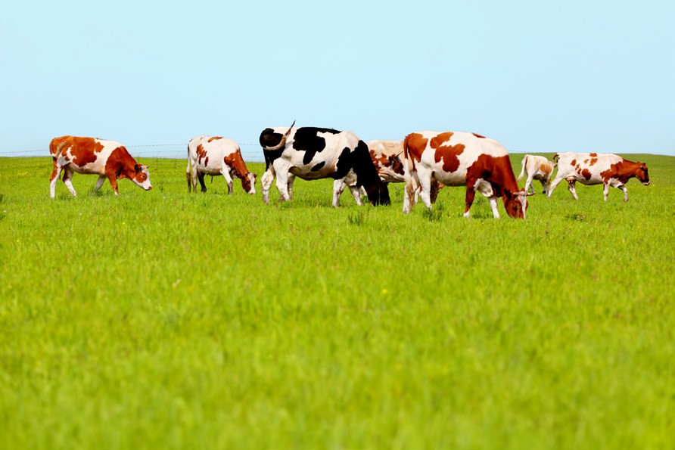

62

Year 4 – Block 5 – Lesson 9 4.22

Apostrophe quiz

Select the correct answer for each of the following sentences.

- The breakfasts belonging to the men
a The men’s breakfasts b The mens breakfast’s c The men’s breakfast’s d The mens’ breakfasts

- The cards belonging to the children
a The children’s cards b The childrens card’s c The children’s card’s d The childrens’ cards

- The music belonging to Thomas
a Thomas music b Thoma’s music c Thomas’ music d Thomas’s music

- The book belonging to James
a James’s book b Jame’s book c James’ book d James’ book’

- The rucksack belonging to the girls
a The girl’s rucksack b The girls’ rucksack c The girls rucksack’s d The girls’ rucksack’s

- The rucksack belonging to the girl
a The girls rucksack b The girl’s rucksack c The girls’ rucksack d The girl’s rucksack’

- The rays belonging to the sun (=it)
  - Its rays
  - I’ts rays
  - It’s rays
  - Its’ rays

- The sadness belonging to Shanya should not …
a Shanya’s sadness should’nt b Shanya’s sadness shouldn’t c Shanyas’ sadness should’nt d Shanyas’ sadness shouldn’t

63

- The anger of Father would not …
a Father’s anger would’nt b Fathers anger wouldn’t c Father’s anger wouldn’t d Fathers’ anger wouldn’t

- The paws belonging to the dogs did not …
a The dog’s paws did’nt b The dogs’ paws did’nt c The dogs paws didn’t d The dogs’ paws didn’t
Year 4 – Block 5 – Lessons 10 and 11 4.23

weather | whether | who’s | whose
medal | meddle | missed | mist
team | teem

Year 4 – Block 5 – Lesson 12 4.24

It was a great day for a game of footbawl. The whether was fine and the game had already started when Joe arrived. ‘Whose in goal?’ Joe asked his neighbour just as the centre forward mist the goal. At the end of the game the meddles were awarded to the winning teem. ‘It’s not fair!’ the losing teem cried as they went home with nothing.
Year 4 – Block 6 – Lessons 1–3 4.25

space | envy | envious | courage
fury | monster | poison | mountain
fame | courageous | spacious | vary
furious | mountainous | poisonous | various
famous | danger | dangerous
64

Year 4 – Block 6 – Lesson 5 4.26

un def in | fin | ish al ite | ing ed es ly ist ise ive
un re | at de | tach | ing ed es able ment

Year 4 – Block 6 – Lesson 6 4.27

un | super | way | highway | finished
dis | inter | merge | national | attach
in | anti | marine | twine | create
re | auto | do | aircraft | marine
sub | cover | man | natural | lock
do | matic | drive | evitable

65

Year 4 – Block 6 – Lessons 9–11 4.28

happy pretty easy sleep ly greedy clumsy
angry

gentle simple humble ly
noble

basic frantic ly
dramatic

66

