Year 5/6 Home Learning for Spring 2
There’s a division of labour for the second half of this term. Year 6, you all now have a log in for the SATS boot camp website - https://www.satsbootcamp.co.uk/sbc/. Each week of this half term, we would like you to choose from one of the Practice SATs Tests section. In maths, this is either Arithmetic or Reasoning, and in English, you have the choice of Spelling, SPaG or Reading. Don’t use the past papers section, as we will be using some of these in class after the Easter holidays. Complete the test online. If there are any questions that you find difficult, make a note of them and we can work on them together in school.
Task | Hand-in date
Maths  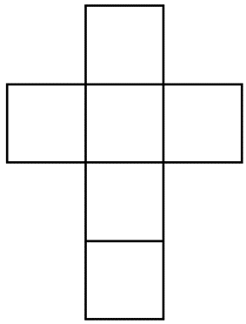  Following our work on 3D shapes, you should now be familiar with nets. Here is a net for a cube. There are 10 other different nets that can be used to make a cube, not including nets that have been reflected or rotated. Can you find them all? Draw them on squared paper (Try not to look them up online!). | 04.03.20
Topic / Literacy  Research a traditional dish that would have been eaten by the Ancient Greeks. Present the recipe and instructions for making the dish as artistically or creatively as you can. Why not make the dish and try it out on your family! | 11.03.20
Science – Earth and Space  Create a fact file about one of the following – a famous astronaut, astronomer, or an event in space exploration. You could present your information as a poster, a radio broadcast, a song, a poem, or in character as the person you have researched! | 18.03.20
Literacy – Proof reading  Below is a short passage about the Olympic Games. Re-write it out in your homework book, correcting the spelling and punctuation. This includes: capital letters to start sentences and for proper nouns, full stops at the end of sentences, commas (or dashes) for clarity and apostrophes for possession (there’s only one of these!). There are also 5 misspelt words to identify and correct! You may choose to break it up into more than one paragraph. | 25.03.20

the greeks loved sport and the olimpic games were the bigest sporting event in the anceint calendar the games began over 2700 years ago in olympia in south west greece every four years around 50000 people came from all over the greek world to watch and take part the ancient games were also a religous festival held in honour of zeus the king of the gods there were no gold silver and bronze meddles winners were given a reeth of leaves and a heros welcome back home athletes competed for the glory of their city and winners were seen as being touched by the gods

