Flag Investigation - During an Olympic Games many national flags are on display.
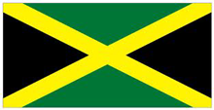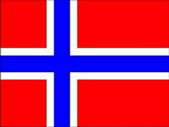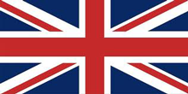
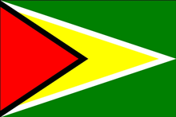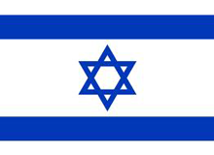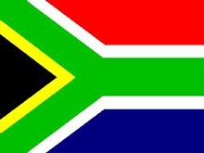

Choose a flag – either one of the flags shown above, or another of your choice. Investigate the following:-
1. What shapes can you see in it? Can you describe them and their angles?
2. Does the flag have any lines of reflective symmetry? If so how many lines?
3. Can you find any pairs of parallel lines? If so mark them on your flag.
4. Are there any lines perpendicular to one another?
5. Can you find a way to classify the shapes in your flag?
Now try another flag!

