



Meet our Safeguarding and Child Protection Team

# Mrs. Tonya Stirrup

##### **Safeguarding Lead**

##### **Deputy Safeguarding Lead**

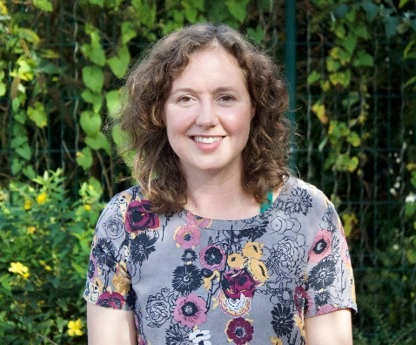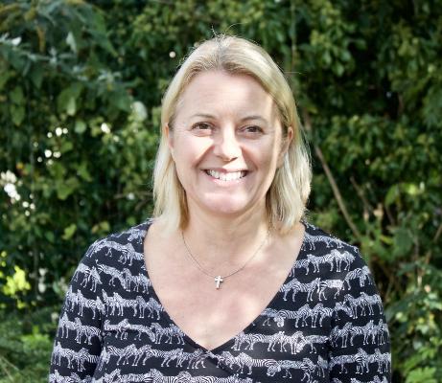 **Safeguarding Lead**

**Mrs. Sandra Maggs**

# Mrs. Sophie Mrs Tonya Stirrup

# Hedley- Clark

##### **Team members**

Mrs. Sam Wilkinson

Mrs. Hilary Priest

If you have concerns for a child you can contact us at school on 01803 862018

or phone the DCC Multiagency Safeguarding Hub (MASH) on 0345 1551071

or you can also email Mrs Priest at head@the-grove-primary.devon.sch.uk