Y2 Home Learning
Beech, Lime and Willow Class
- Read 3 times a week. This is really important.
- Read and spell these words: You could cut them out and make flash cards
again | half | money
water | people | busy
clothes | who | many
any | path | bath
plant | pass | grass
class | past | last
fast | after | beautiful
great | break | every
because | Mr | Mrs

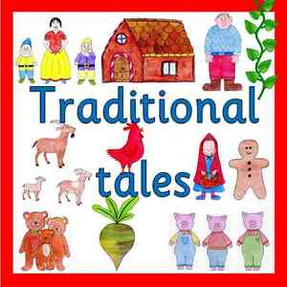
How many traditional tales do you know?
Can you retell a story to your family?
Write or draw a story map of your favourite traditional tale. We look forward to seeing them all.

Continue to practise using money. Adding notes and coins. You could use the game https://www.topmarks.co.uk/money/toy-shop-money

Learn 2x ,5x and 10x tables
